Annex 06. Stakeholder Analysis

Integrated Water Resources Management of Mira,
Mataje and Carchi-Guáitara binational basins (Colombia-Ecuador)
Project # 00109652

Stakeholder Analysis – Carchi-Guáitara, Mira and Mataje Basins

Yina Paola Pantoja Villota
Contributions from Aracely Pazmiño Montero
January 24, 2019

TABLE OF CONTENTS

2. STAKEHOLDER MAPPING METHODOLOGY 4
2.1 Applied Conceptual Approach 4
3.2 Analysis Methodology 5
3.3 Limitations of the stakeholder methodology 7
4. STAKEHOLDER ANALYSIS RESULTS 7
4.1 General identification of Stakeholders 8
4.2 Stakeholder identification and characterization in the Basins subject to study 9
4.3 Stakeholder Analysis in the Basins Subject to Study 10
4.4 Stakeholder identification and characterization in pilot projects 13
4.5 Stakeholder Analysis in pilot projects 14
5. CONCLUSIONS 17
6. APPLIED TERMINOLOGY 18
7. BIBLIOGRAPHY 18

1. BACKGROUND
The Global Environment Facility (GEF) policy on ‘stakeholder participation’ establishes the basic principles and mandatory requirements for their participation in the management and operations of the GEF in order to promote transparency, accountability, integrity effective participation and involvement. The policy is ruled by constructive, receptive, responsible and transparent participation of the stakeholders, which in turn supports just, balanced and involved participation in the management and operations of GEF (GEF, 2017).

The participation of stakeholders or interested parties in the project is key to the success of the initiatives financed by the Global Environment Facility – GEF. GEF points out that such participation may improve performance, it allows for better design and execution of the financed activities, reduces risks; and it takes into account the social and economic needs of the impacted parties. From this view point, GEF has introduced the ‘Policy on Public Participation’ since 1996 (GEF, 2012). Similarly, GEF has established rules and requirements regarding the participation of stakeholders through the ‘Minimum standards of environmental and social safeguards’ (GEF, 2015). Such standards must include the need to interact with the interested parties, the target groups, the local civil society, and the indigenous peoples, amongst others. July 1st, 2018 marked the effective date of the new ‘Policy on Stakeholder Participation’ (GEF, 2017).

As far as the activities financed by GEF are concerned, the policy reaffirms and enforces GEF’s commitment to ‘allow free access to all information which is not deemed confidential as well as free access to interview the main local groups and communities during the whole project cycle, and for them to participate when needed.’ Thus, for effective and meaningful stakeholder participation to take place, it takes constant commitment and action, including appropriate resource allocation, throughout the whole process to identify, design, execute, follow-up and assess the activities financed by GEF (GEF, 2017).

On the other hand, UNDP is committed to ensuring significant, effective and informed participation of key stakeholders in the formulation of UNDP’s programs and projects, guidelines and guidance given by the SES (Social and Environmental Standards) (UNDP, undated). The involvement of such stakeholders seeks to identify their priorities and it will provide opportunities for them to express their opinions at any given point in time of the decision-making process regarding issues that may impact them directly, plus there will be opportunity for the project teams to take into consideration and respond to such opinions. As a result, this is a constant process that may gather the following elements at various levels: analysis and planning of key stakeholders, information disclosure and broadcast, significant consultation and participation, dispute settlement and redress of grievances, constant submission of reports before communities and impacted stakeholders; and their engagement in the follow-up and assessment processes (UNDP, 2014).

Mapping, analysis and participation of key stakeholders will take place in such a way that it will be sensitive to gender and culture, inclusive and without discrimination. It will always strive for the identification and delivery or participation opportunities among the vulnerable and marginalized groups. Participation opportunities will be appropriate as far as cultural conditions are concerned and they will be adapted to linguistic preferences and to the decision-making processes of each identified interest group, including less favored or marginalized groups. Similarly, measures will be put in place to ensure that such groups interact with the key stakeholders effectively when the conditions for inclusive participation are not favorable (UNDP, 2014).

Within the framework of GEF’s sixth replenishment and taking into account the strategic importance of Mira, Mataje and Carchi-Guáitara binational basins, UNDP along with the Ministry of Environment and Sustainable Development of Colombia (MADS) and the Water Secretary of the Ecuadorian Government (SENAGUA) prepared the PIF (Project Identification Form), a conceptual note of the project ‘Integrated Water Resources Management of Mira-Mataje and Carchi-Guáitara Binational Basins, Colombia – Ecuador.’ This project intends to promote the Integrated Water Resources Management (IWRM) in the three basins shared by the two countries, thus strengthening the managerial and institutional capacities at the regional, local and community levels in order to achieve environmental and social-economic benefits.

The project document (PRODOC) is currently being developed. It is the framework where this mapping and diagnosis of stakeholders of the bordering basins of Ecuador and Colombia was carried out. The document herein is an integral part of the situation analysis required to offer continuous, timely and appropriate information of the interested parties while following the institutional mandates and policies of GEF and UNDP as the guiding principles for the present analysis and for the stakeholder engagement plan to be implemented in the future.

2. STAKEHOLDER MAPPING METHODOLOGY

2.1 Applied Conceptual Approach

Participation increases the effectiveness of a project because when input and perspectives from a variety of stakeholders is integrated, it helps to achieve the appropriate project design and ensure stakeholders’ commitment to project objectives. Participation empowers people (ODA, 1995) and it increases the project’s sustainability because it supports the development of the skills and relationships among stakeholders and project implementors. To ensure project success, awareness, communication and training should also be integrated throughout the whole project as these are considered streamline tasks (Lüthi et al., 2011).

In the end, individuals participate out of their own initiative and even though some participation is compensated for, no one is obliged to be part of a participatory process. People must have an interest and believe that their integration to the project is for their own benefit or for common good. It is worth mentioning that inadequate integration of stakeholders may contribute to the formation of opposition to a project, whereas negative feedback gathered during the consultation and engagement process should be seen positively since it shows the degree of political and social acceptance of the proposed actions.

It must be noted that participatory processes are complex and time-consuming, amongst others, given the fact that a trusted relation among participants must be established first. However, stakeholder integration from the very beginning often saves time ahead when problems arise and they must be solved in a way that otherwise may hinder the implementation and operation of the system (ODA, 1995). Thus, integration may save the project’s funds in general terms so participatory processes must be deemed as an investment by the entity in charge of implementing the project.

Participation of the interested parties shall be free from manipulation, interference and intimidation; and it shall be carried out on the grounds of timely, relevant, understandable and accessible information as well as in a culturally appropriate format. Participation implies interactions among identified groups of individuals and it provides the interested parties with the opportunity to express the concerns and opinions and to be assured that such information will be taken into account when making decisions about the project.

3.2 Analysis Methodology
Stakeholder analysis was carried out in four phases:

- Primary and secondary information gathering
A first list of stakeholders was compiled through an analysis of stakeholders identified in various documents related to the basins in the two countries. In addition, stakeholder databases were reviewed from previous processes such as the First Binational Forum: Governance, Eco-systemic Services, Climate Change and Integrated Management of Mira and Mataje Binational Basins led by the WWF. Information was also gathered from provincial and regional planning instruments: POMCA, POMCH, Water National Plan DH Mira and PDOT for the Carchi province, which were developed by the competent institutions. The information was complemented by means of participatory research tools within the project partners workshop (June 26 and 27, 2018); and through consultations during binational workshops with local community stakeholders from the three basins (September 21st and November 21st, 2018).

- Stakeholder Categorization
At the outset of the stakeholder analysis, stakeholders were grouped and assigned categories based on specific information.

This process yielded a stakeholder typology which allowed differential analysis of stakeholder relations, mandates and importance (del Castillo, 2014). This step was not only limited to the exclusive realm of organizations that work for or promote environmental initiatives, but it also included stakeholders with a social/community mandate that have positive or negative influence on the Integrated Water Resources Management and, as a result, on water governance. The following criteria were considered for the stakeholder categorization:

- Indigenous peoples traditionally settled in the basin.
- Black or African-descendant communities settled in the basin that may have occupied wastelands in riverside rural zones, according to their traditional production practices; and may have formed a community council under the provisions of Law 70 from 1993.
- Organizations that associate or unite farmers.
- Organizations that associate or unite productive sectors.
- Individuals who provide aqueduct, drinking water and / or sewage services.
- Non-governmental organizations whose exclusive purpose is the protection of the environment and renewable natural resources, as well as the issues related to water governance.
- Community Action Boards, irrigation boards, drinking water boards and risk boards.
- Universities, educational institutions or other types of academic bodies that carry out research or environmental studies in the basin or may be interested in it.
- Territory entities with jurisdiction in the basin (Municipalities, Counties, Departments and Provinces).
- Stakeholders who know or work in favor of keeping the potential of the basin.
- Stakeholders who may have interest in the project.
- Stakeholders who have information, knowledge or experience in Integrated Water Resources Management in the Basin.
- Stakeholders who have information, knowledge or experience in topics developed in the project components.

Stakeholders were then classified into categories under the following criteria - first in relation to the management realm and second in relation to the type of organization.

-Territory management realm: The space where the stakeholder carries out their actions or performs their social role, which may be local, regional, national or international.

-Type of organization: this refers to the type of organization, which included the following categories:

- Organizations of indigenous peoples and African descendants: whose objective is to defend the inner interests of the indigenous peoples and African-Colombian communities.
- Social / Community Organizations: These are groups formed by inhabitants of a neighborhood, village, settlement, municipality, county, etc. in order to enforce their rights, to exercise self-management, defend and promote their common interests. They are organizations similar to JAC (Community Action Boards), Aqueduct Boards, irrigation boards, community associations, etc.
- Non-government Organizations - NGO: These are organizations whose purpose is to promote the community’s development thoroughly and defend their collective interests. Foundations, corporations and common-benefit associations are part of this type of organizations.
- Public government institutions: They are stakeholders whose corporate purpose is established by a legal act within the framework of the competences and functions assigned by the State structure. Such mandate determines the institution’s responsibility regarding environmental situations.
- Sector of business organization: this includes the stakeholders of different productive sectors (palm, sugar cane, potato growers, livestock), etc.
- Academia: this relates to all the institutions with an academic nature such as universities, institutes, etc.

- Stakeholder Characterization
Two variables were taken into account for stakeholder characterization (influence and position), which allowed, on the one hand, value stakeholders and, on the other hand, visualize in a snapshot the type of stakeholders they are. The concepts are detailed below.

-Influence: this is the power a given stakeholder may have over a project as to control decision-making, facilitate implementation or exercise influence that may impact the project positively or negatively. Such power may derive from the organization’s nature, the stakeholder or their position in relation to the other stakeholders. It is also deemed as the ability to “make things happen” or mobilize resources. This variable was valued with the following scale:

- Low
- Medium
- High

-Position in the project: It means the position the stakeholders will adopt towards the project. It facilitates organizing the selected stakeholders according to their level of support or opposition. Positions were valued based on the following range:
- In favor
- Against / opposing
- Indifferent or neutral: the stakeholder is not interested or refrains from participating or does not perceive a need or lacks information.

- Valuation
The proposed variables have been gathered in an Excel matrix where a value and/or a score was given to the influence and position variables regarding the project and then a classification was given to each one of the stakeholders. This valuation determines the type of action or response the stakeholder is expected to have in each case.

3.3 Limitations of the stakeholder methodology

One element that was identified as a limitation in the applied exercise was the fact that it is based on the perceptions from different people who were asked, as well as on the views of the staff of the formulating team. This limitation is specifically shown in the stakeholder characterization (influence and position variables) since it was assessed considering the information gathered from the perception of the spaces and stakeholders linked to the process. Such characterization and the mapping exercise itself must be constantly reviewed by the project executing members since the exercise shows a specific situation before the beginning of the project, and it may change from PRODOC design until the implementation of the project.

4. STAKEHOLDER ANALYSIS RESULTS

Stakeholders of Carchi-Guáitara, Mira and Mataje binational basins were identified. These basins are the main water resources shared by Colombia and Ecuador in the basin of the Pacific Ocean (Figure 1). These resources represent a significant source of water that is essential to the social-economic development and the integrity of the ecosystems, which provide important ecosystemic services at the local and regional levels.
Figure 1. Carchi-Guáitara, Mira and Mataje Binational Basins
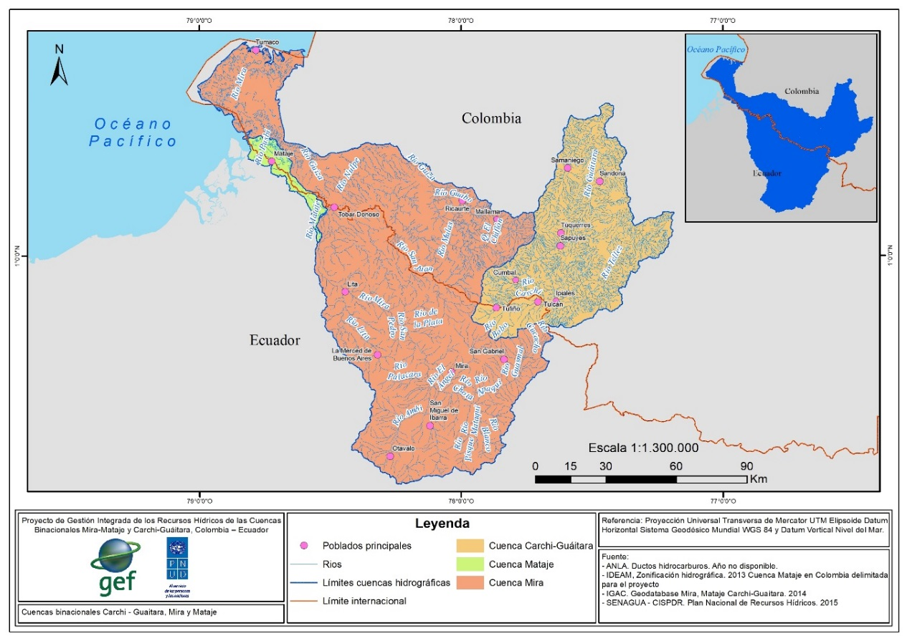
Source: Analysis of the situation and use of the water resource. Arévalo, A y Ríos V. 2019

4.1 General identification of Stakeholders

Initial activities focused on tracking stakeholders based on the information found in the Planes de Ordenamiento y Manejo (Organization and Management Plans) of Guiatara Basin, the Binational Plan of Integrated Water Resources Management of Carchi-Guáitara, Mira and Mataje transboundary basins, the Territory Organization and Development Plan of the Carchi province, Water National Plan DH Mira, the summary of the First Binational Forum: Governance, Eco-systemic Services, Climate Change and Integrated Management of Mira and Mataje Binational Basins, the directory submitted by WWF Colombia, information from internet searches and the web archive of the different institutions, amongst others.

A first version of the stakeholder list was compiled to initiate the data gathering phase for the pilot projects and for each basin of the two countries. At the same time, a national, regional and local list was started to be compiled, and it was useful for the project’s general point of reference. Annex 1 “Preliminary version of the stakeholder list.”

4.2 Stakeholder identification and characterization in the Basins subject to study

In total 207 relevant stakeholders were indentified - 93 were identified in Mira, 62 in Carchi-Guaitara and 52 in Mataje basins. The stakeholders of public government institutions were the most freequent stakeholder represented in all basins, followed by NGO’s and social/community organizations. The stakeholders with the lowest representation in all the basins were those from the business sector. (Figure 2).

Figure 2. Number of Stakeholders per organization type in Carchi-Guaitara, Mira and Mataje Basins (Ecuador and Colombia)

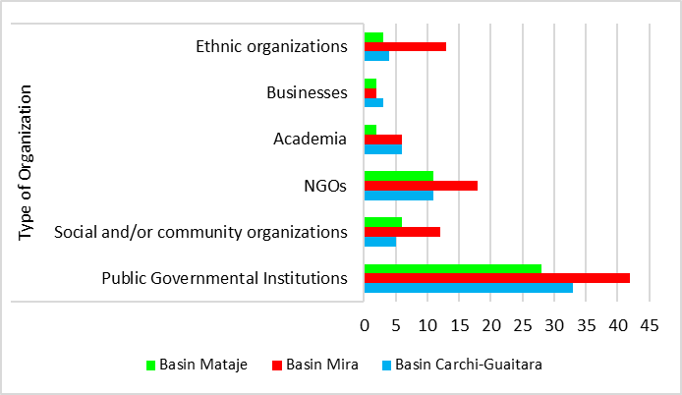

It was observed at the start of the activity that while there is a high number of stakeholders involved in water management at different levels, there are no significant collaboration or participation mechanisms in place. For example, there was a clear lack of management that may incorporate the participation from the private sector and users in general through the appropriate mechanisms.

In regards to the management realm, Figure 3 shows that national level stakeholders predominate in all basins, followed by stakeholders at the local and regional / provincial levels. International stakeholders are the least frequently represented in all basins except Mataje, which had slightly more international organizations present than local organizations. This may suggest limited capacity of local organizations and their engagement among communities in this basin.

Figure 3. Number of Stakeholders per management realm in Carchi-Guaitara, Mira and Mataje basins
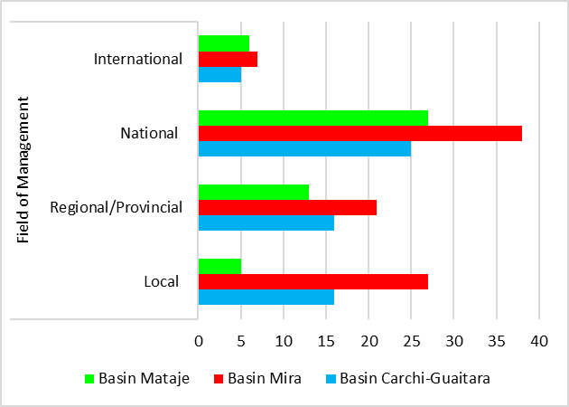

4.3 Stakeholder Analysis in the Basins Subject to Study

The stakeholder analysis established a detailed stakeholder list to identify priority stakeholders that may be considered impacted by, related or relevant to the objective, components and results of the project. As it was mentioned above, the stakeholder analysis exercise is a dynamic activity, which must be ongoing with the information updated regularly because the stakeholders and their interests may change in relation to the project.

Taking into account the stakeholder analysis carried out for the three basins, most stakeholders are considered to hold a favorable position towards the project (Figure 4a). A favorable position is mainly shown by institutional stakeholders, mostly through the Ministries of Environment and Foreign Affairs. There is also important stakeholders within the municipality, department and provincial territory entities such as Corponariño, Nariño’s Governor’s Office, Province GADs (Carchi, Imbabura and Esmeraldas). It is worth mentioning that these institutions seem to have good working relationships with one another. Finally, the activity considered the social and community organizations that play important roles in their communities since their mandate is to promote community development and serve as meeting channel between any project or activity and the communities they represent.

Influence levels vary somewhat but it is interesting to note that influence fluctuates between high and medium levels, which means that there is some leadership with the competence to call, manage, and legitimate participation in the project. There are some stakeholders with visible influence in the territory and as a result they represent a greater interest in management and relations (Figure 4b). Overall, in relation to the level of influence in decision making and the ability to generate impact on public opinion, the main stakeholders in order of influence are the Ministry of Environment, IDEAM, INHAMI, Mancomunidad de Gobiernos Descentralizados Provinciales del Norte, and finally the irrigation Boards and the Drinking Water Boards, along with the Aqueduct Administrative Boards, and the Community Action Boards, etc.

Figure 4. Stakeholder characterization in relation to the project a) Position, b) Influence
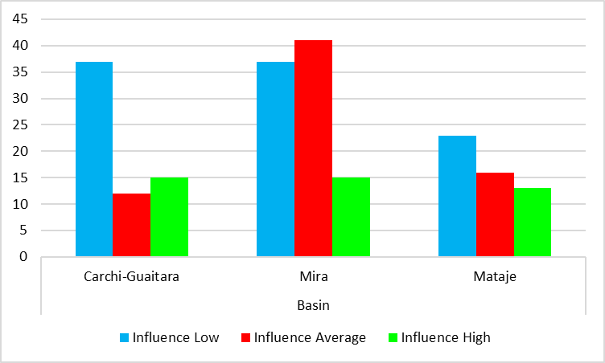

a)

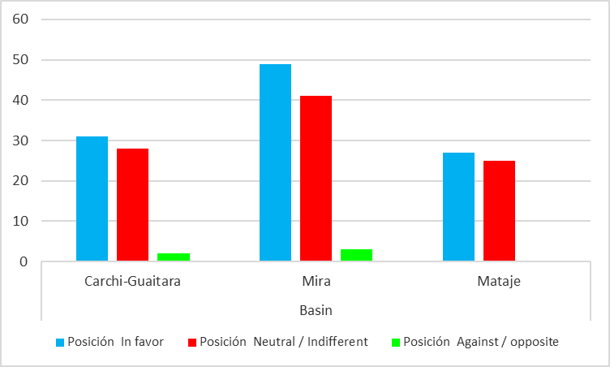
b)

The stakeholders analyzed in each of the Basins were classified as key, primary, secondary and tertiary stakeholders (Exhibit 1-3) as described below:

- Key Stakeholders: They are stakeholders who have medium and high influence and a favorable position towards the project. These stakeholders are largely from government entities that have a shared mission of integrated water resources management; plus, they have high capacity to impact the decisions of other stakeholders regarding water management in the basin. Key stakeholders include the Ministries of Environment, Foreign Affairs, territory entities (Nariño Governor’s Office, Corponariño, GADs Provincial, IDEAM, INHAMI). The involvement of these stakeholders has been initiated from the early stages of the process in the Preparation of the Project Document (PPG). Several of these stakeholders have been identified as partners and have contributed to the project in a decisive manner, since they have become involved in the decision and operation structures of the project components.
Some NGO’s are also considered Key Stakeholders, including different organizations that work in the region as they represent possibilities to strengthen the project as they can coordinate and complement project goals and objectives. Key NGOs include the United Nations Development Program – UNDP, and WWF-Colombia and these organizations are important for the project’s development and implementation as they are project partners. The World Food Program – WFP is another key stakeholder with which complementary work synergies will be established in the basin and CAMAREN, which will provide support to the suggested training sessions in component 3.

The social and / or community organizations, represented by the administrative boards of village aqueducts, the Community Action Boards, the watering boards, which are formed by leaders of the territory; and their management intends to respond to the requirements concerning drinking water, conservation of water resources, basic sanitation, amongst others. Additionally, they are stakeholders with legitimacy within their communities and they are considered as key stakeholders within the governance process in the basins.

Academia is another key stakeholder represented by the National Learning Service – SENA, Nariño y Mariana universities, which will developed and deliver the training processes proposed in the project; These stakeholders will share all knowledge and information developed during research projects they carry out in the basins.

- Primary Stakeholders: These are stakeholders who are considered to have low influence and a position in favor of the project. They should be incorporated onto the project as the process unfolds and actions may be implemented for their strengthening; especially in order to improve their capacity to participate, strengthen their influence and level of involvement in water management. This aspect turns out to be especially important to enable groups that have historically been excluded, such as Comuna La Esperanza, Comuna Ancestral de Indígenas Pasto La Libertad, ROSCGAE-Sierra Norte, so that they may participate actively and positively in the long-term sustainable management of their territory.

- Secondary Stakeholders: These are social or institutional stakeholders who have medium and high influence and a neutral or opposing positions towards the project. In short these are stakeholders that do not share or do not know the project objectives and the potential benefits it represents. They may play a favorable or unfavorable role in the IWRM (Integrated Water Resources Management) process depending on the reasons for their low level of support. Specific work needs to be done to better engage two indigenous groups (Pastos and Awá) from this group of stakeholders. This is why it is recommended that the project obtain information about their objectives, expectations, alliances, commitments, etc. It is also recommended that meaningfulengagement actions be carried out to facilitate the free, prior and informed consultation process.

- Tertiary Stakeholders: These are stakeholders with low influence capacity and a neutral or indifferent position towards the project. They have few possibilities to contribute to the integrated water resources management. However, it is desirable to carry out information activities and perhaps explore some approach options with these stakeholders,

Based on the analysis herein, it may be observed that there is an on-going participation process in the three basins, which has been able to capitalize on the presence of different stakeholders. However, it is also noticeable that such participation is mainly institutional and mostly from one management realm. This implies some weakness in the process in regards to the participation of the civil society. This in turn poses some concerns like whether specific participation spaces have been presented, whether they have been binding, and whether they have had clear engagement mechanisms for each one of the stakeholders who have direct influence on the integrated water resources management in the Carchi- Guaitara, Mira and Mataje basins.

It is imperative to note that a very important binational participation opportunity has been identified: the Sub-commission of Water Basins and Environmental Issues framed within the Neighboring and Integration Commission between Ecuador and Colombia (COVIEC). This process has formulated the 2014-2022 Border Integration Binational Plan. However, based on the information collected, this body has not yet been able to establish itself as a space that strengthens the work outcomes, the collaboration between State and the civil society, articulates and fosters the binational agenda of the governments or integrates the needs and expectations of the stakeholders and the local and regional organizations they work with.

Similarly, there is the Basin Council of the Güiza river, incorporated in 2008, during the drawing-up of the Basin Organization Plan, which is an important space to foster the process and ensure the call and active participation of key stakeholders. When stakeholders are trained, they become multipliers of knowledge, process implementers, and responsible for verifying due maintenance and follow-up on the agreements arisen from the Project.

4.4 Stakeholder identification and characterization in pilot projects

The project will put in place three innovative interventions (pilots) to evaluate social-economic and environmental benefits of the IWRM application in the basins. The interventions correspond to two binational pilot projects. The first binational pilot is the integration of the hydro-meteorological information system and household wastewater treatment by means of vermifilters. The second project is a national pilot for community Bioengineering Works in Colombia.

A total of 107 relevant stakeholders were identified for the pilot projects of the treatment plants (46 stakeholders), the hydro-meteorological network (35 stakeholders) and the Bio-engineering work (26 stakeholders). The stakeholders of government public institutions were the most common group represented in all the pilot projects, followed by NGO’s and social and / or community organizations. The least represented stakeholder in all the basins was the business sector (Figure 5).

Figure 5. Number of Stakeholders per organization type in each pilot project.

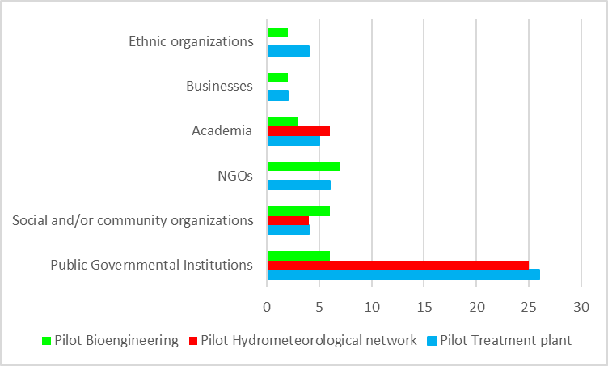

This exercise allowed for the identification of several stakeholders related to the pilot projects at different management levels. The priority was the participation of government entities, followed by social and/or community organizations as the beneficiaries of the learning from and the implementation of the techniques exhibited by the pilot projects.

In regards to the management realm, Figure 6 shows that local stakeholders are more common in all the pilot projects. They are followed by the regional/provincial level; and international stakeholders are the least represented.

Figure 6. Number of stakeholders per management realm
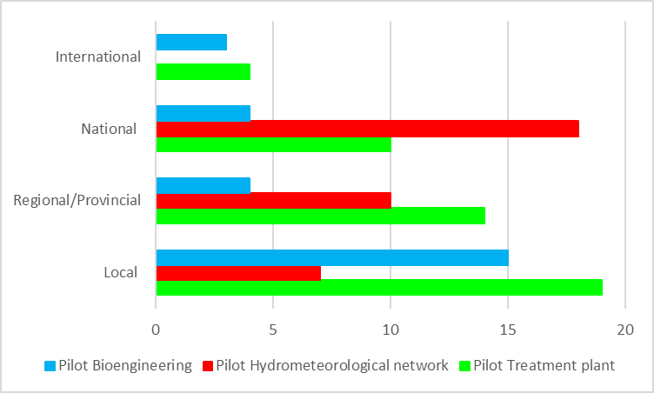

Stakeholder Analysis in pilot projects

Bearing in mind the analysis conducted for stakeholders in the three pilot projects, it can be said that the majority of stakeholders have a favorable position for each pilot project (Figure 6a). This position is mainly found among stakeholders who form government institutions at the different management levels, but social and community organizations are also highlighted since they play important roles within their communities. High and medium levels of influence are to be noted, which means there is leadership able to call, manage and legitimate. Some stakeholders have visible influence in the territory and, as a result, they are expected to show greater interest in the management and relations when each pilot project is implemented.
Figure 6. Stakeholder characterization towards projects a) Influence, b) Position

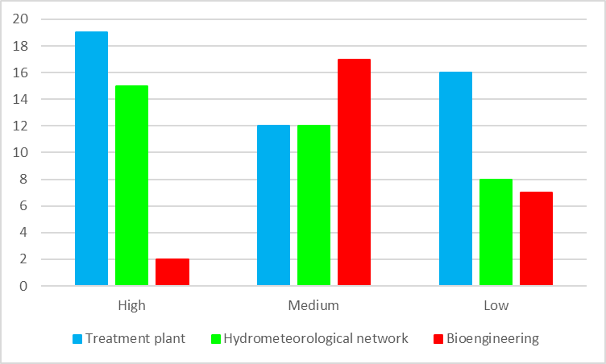
a)

b)
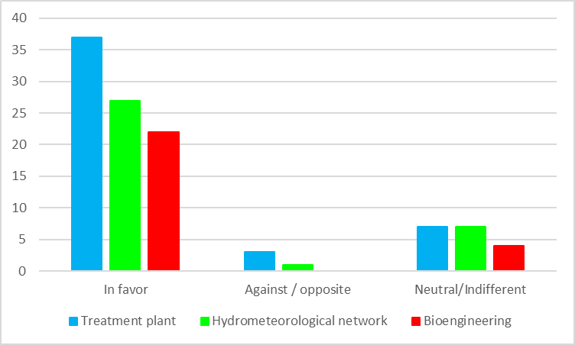
The stakeholders analyzed in each one of the pilot projects were classified into key stakeholders, primary stakeholders, secondary stakeholders and tertiary stakeholders (Exhibit 4-6). Each group was analyzed to determine whether they are causing agents of the issue that would impact the pilot project or whether they are beneficiaries. As a result of the analysis, three groups were identified and they are described below.

- Government institutions
As far as government institutions are concerned, national entities are to be highlighted, such as the Ministry of Environment and Sustainable Development, Mancomunidad del Norte del Ecuador, IDEAM, INHAMI. There will also be participation and leadership from territory entities such as Nariño Governor’s Office, Corponariño, municipality mayor’s offices, province and municipality GAD’s. These are important stakeholders given their knowledge in the areas of study and the information they have gathered about the sub-basin for a long time. Additionally, they are the regulatory bodies of environmental affairs and they are responsible for the formulation and deployment of planning instruments in the basins, which the pilot project actions are a part of.

- Local communities and organizations
Some of the key stakeholders are the representatives of the communities that inhabit the municipalities or parishes where the pilot projects will be implemented. Some outstanding stakeholders are the Community Action Boards (JAC) and inhabitants of areas adjacent to the rivers.

- Conservation and sustainable development organizations
On the other hand, there are several local organizations in the areas where the pilot projects will be implemented. They receive cooperation support to execute actions for the Integrated Water Resources Management – IWRM. They also carry out projects that seek to generate local governance capacities such as the work of La Planada Reservation, the Pialapí Pueblo Viejo Integrated Reservation, Los Tirapuentes Ecological Group Foundation, Los Colibríes de Altaquer Ecological Foundation (FELCA), Los Innovadores de San Isidro (GELISI) Ecological Group. These are organizations where coordination will be promoted to implement the pilot projects.
- Academia
Academia is a key stakeholder within the development and implementation framework of the pilot projects. They will be the research labs and the labs to generate information and conduct the training processes.

5. CONCLUSIONS

The results of this stakeholder mapping and analysis reflect the current situation of the project in the basins. However, attention must be given to perceptions of the stakeholders as they may shift along with the progress in the relationships, and as the project positions itself in the Carchi-Guaitara basin.

The identification of each group of stakeholders in the project is different. Stakeholders maintain different positions as they represent different sectors, hold different information about IWRM as their logistic, financial, technical and political capacities are different, and they act in their own specific ways according to their competences and/or future view of the basins.

Similarly, stakeholder identification in the project is heterogeneous. For example, local communities and African-Colombian and peasant communities, as well as indigenous peoples, have different interests and positions that do not necessarily align with the others. This is true not only within the framework of difference, but also in counterpart interests. As such, the Stakeholder Engagement Plan recommends the organization of spaces and dialogue processes for indigenous peoples before the engagement of the other stakeholders in more plural spaces. In order to respond to stakeholder diversity, local facilitators will also be integrated into the project at the basin level in the two countries. (See stakeholder engagement plan).

The area where each stakeholder acts is also specific, as well as their own relationship networks. This is the reason why in some cases, and in order to ensure the interest and the appropriateness of the spaces allocated for the development of result 2 of the project (SAP), the stakeholder engagement plan must include the call for dialogue in specific areas of each Basin, since this approach will help to ensure greater levels of participation and engagement at the local level.

6. APPLIED TERMINOLOGY
The following definitions were used during the stakeholder mapping exercise:
A stakeholder is any individual, who may be part of a group, organization, entity, corporation or institution of the public, social or private sector, non-government organization or international agency that has a direct or indirect relation with the three basins (those who hold information, resources, experience and any form of power to influence decisions).
Key stakeholders are those individuals whose participation is essential and mandatory to achieve the purpose, objectives and goals of the project at hand. They have the power, capacities and the means to decide and influence in vital areas, which may foster or hinder the project’s development.
Primary stakeholders are those who have been identified for having a lot of influence in the decision-making process to implement integrated management.
Secondary stakeholders are those who have direct influence.
Tertiary stakeholders are those in whom fewer efforts will be invested.

7. BIBLIOGRAPHY
Arévalo, A y Ríos V. 2019. anexo del documento de proyecto “Análisis de la situación y uso del recurso hídrico.”

Constitución política de Colombia. 1991. http://www.ramajudicial.gov.co/documents/10228/1547471/CONSTITUCION-Interiores.pdf

Corponariño. 2016. Planes de Ordenamiento y Manejo de la Cuenca - POMCA Guaitara
Plan Binacional de Gestión Integral del Recurso Hídrico de las cuencas transfronterizas Carchi-Guáitara, Mira y Mataje Colombia- Ecuador: Síntesis. Tosse Luna Oscar (Minambiente, Colombia); Iza Cristian (Senagua, Ecuador). Bogotá, DC; Quito: Colombia. Ministerio de Ambiente y Desarrollo Sostenible; Ecuador. Senagua, 2017

Decreto 1640 del 2012. Instrumentos para la planificación, ordenación y manejo de las cuencas hidrográficas y acuíferos

del Castillo, M. 2014. Mapeo de actores, HELVETAS Swiss Intercooperation. La Paz, Bolivia: HELVETAS Swiss Intercooperation.

GEF. 2012. Política sobre participación pública. Consultado en: http://www.thegef.org/sites/default/files/documents/Public_Involvement_Policy-2012.pdf

GEF. 2015. Política de salvaguardas ambientales y sociales. http://www.thegef.org/sites/default/files/documents/Policy_Environmental_and_Social_Safeguards_2015.pdf

GEF. 2017. Política sobre participación de los interesados

Organización Internacional del Trabajo (OIT). 1989. Convenio 169, Sobre pueblos indígenas y tribales en países independientes. http://www.refworrld.org.es/docid/50ab8efa2.html

Pinilla, I. (Recopiladora). 2016. Memorias I Foro Binacional: Gobernanza, Servicios Ecosistémicos, Cambio Climático y Gestión Integral de las Cuencas Binacionales Mira y Mataje

Plan de Desarrollo y Ordenamiento Territorial - Carchi 2031

Programa de las Naciones Unidas para el Desarrollo (PNUD). 2014. Estándares Sociales y Ambientales. http://www.undp.org/content/undp/en/home/librarypage/operations1/undp-social-and-environmental-standards/

Programa de las Naciones Unidas para el Desarrollo (PNUD). 2018. Ayuda Memoria del Taller binacional de inicio de la Preparación del Documento del Proyecto (PPG). 21 de septiembre de 2018. Ecuador

UNDP. s/f. Estandares sociaels y ambienatales. http://www.undp.org/content/undp/en/home/librarypage/operations1/undp-social-and-environmental-standards/

EXHIBIT 1 Stakeholders identified in Basin Carchi-Guaitara

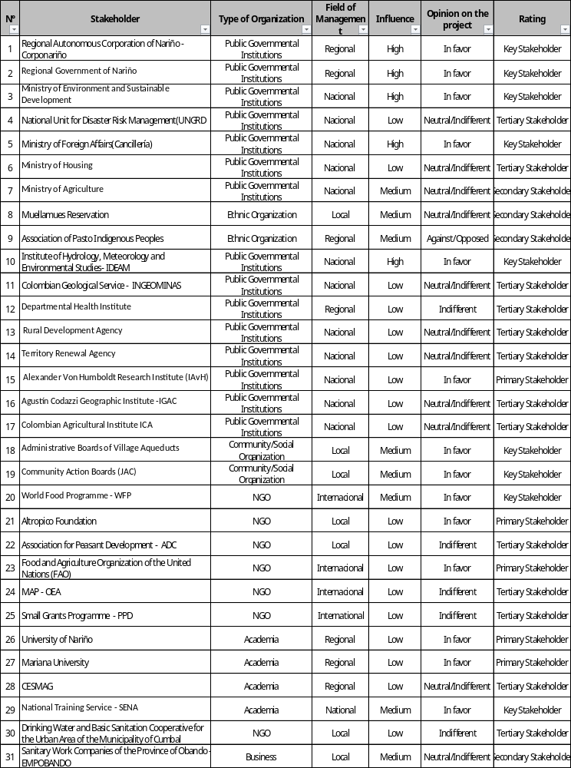
Continuation

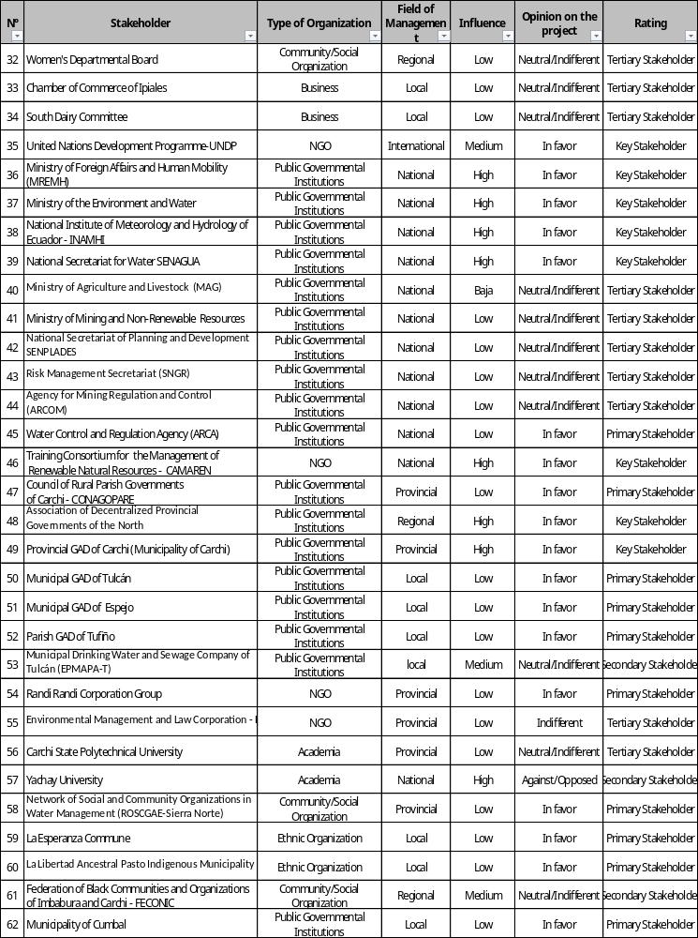

EXHIBIT 2 Stakeholders identified in Basin Mira
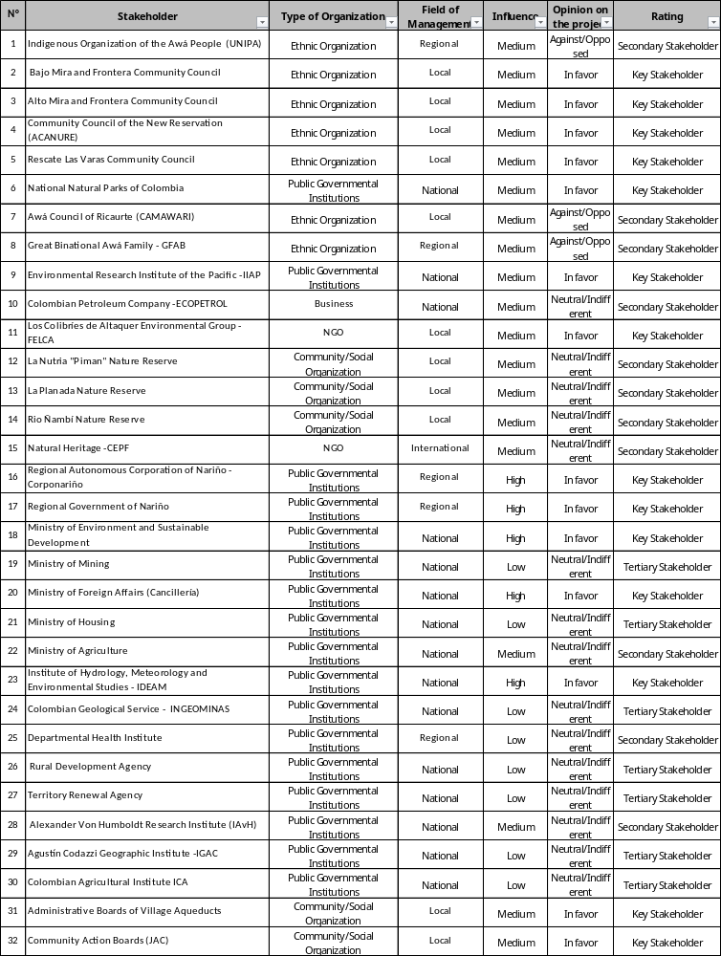

Continuation

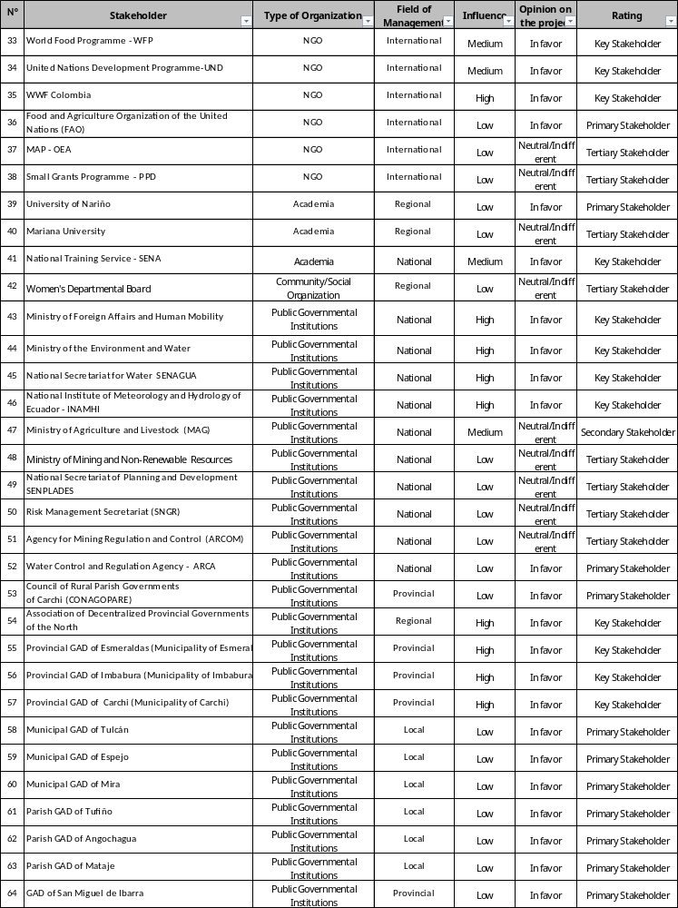

Continuation

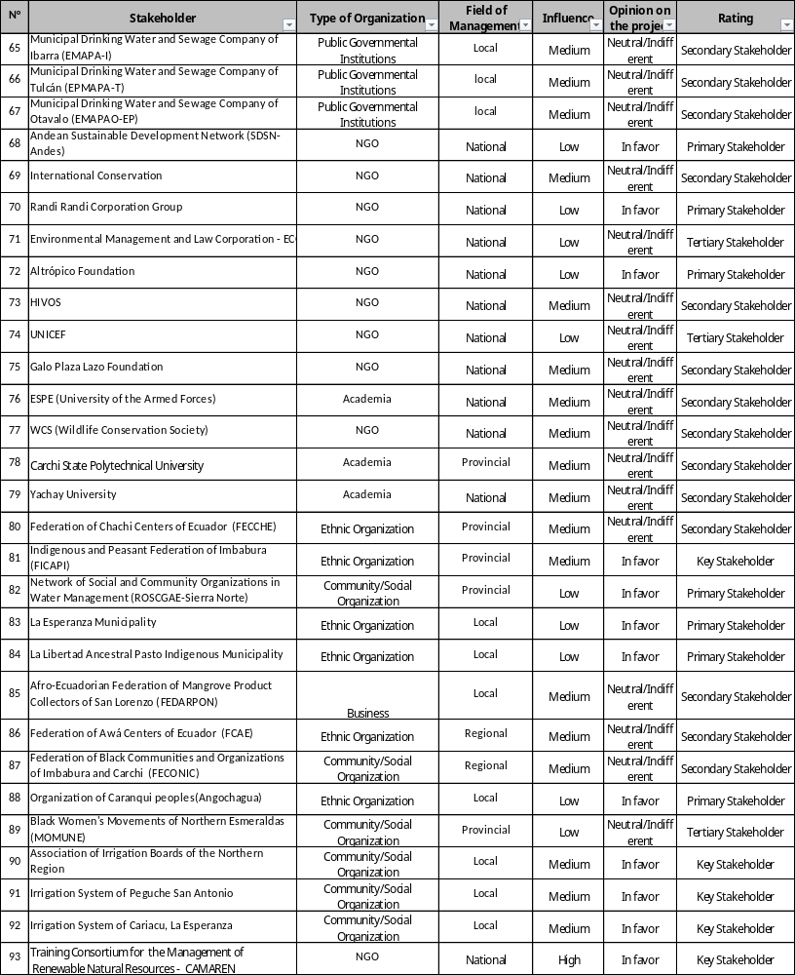

EXHIBIT 3. Stakeholders identified in Basin Mataje

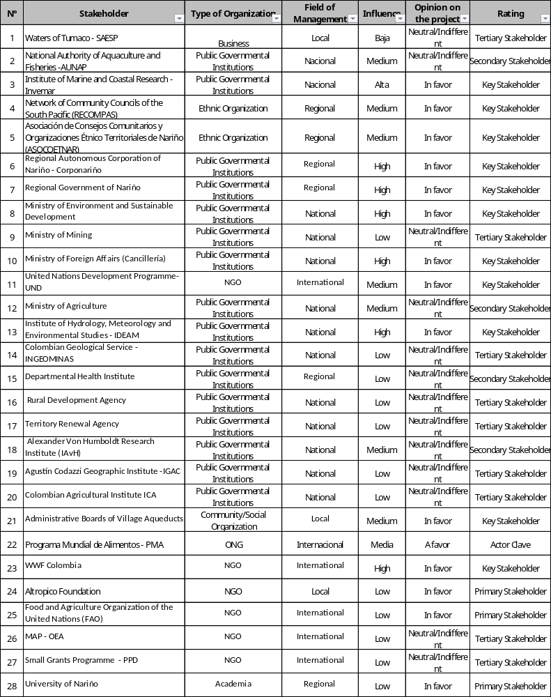

Continuation

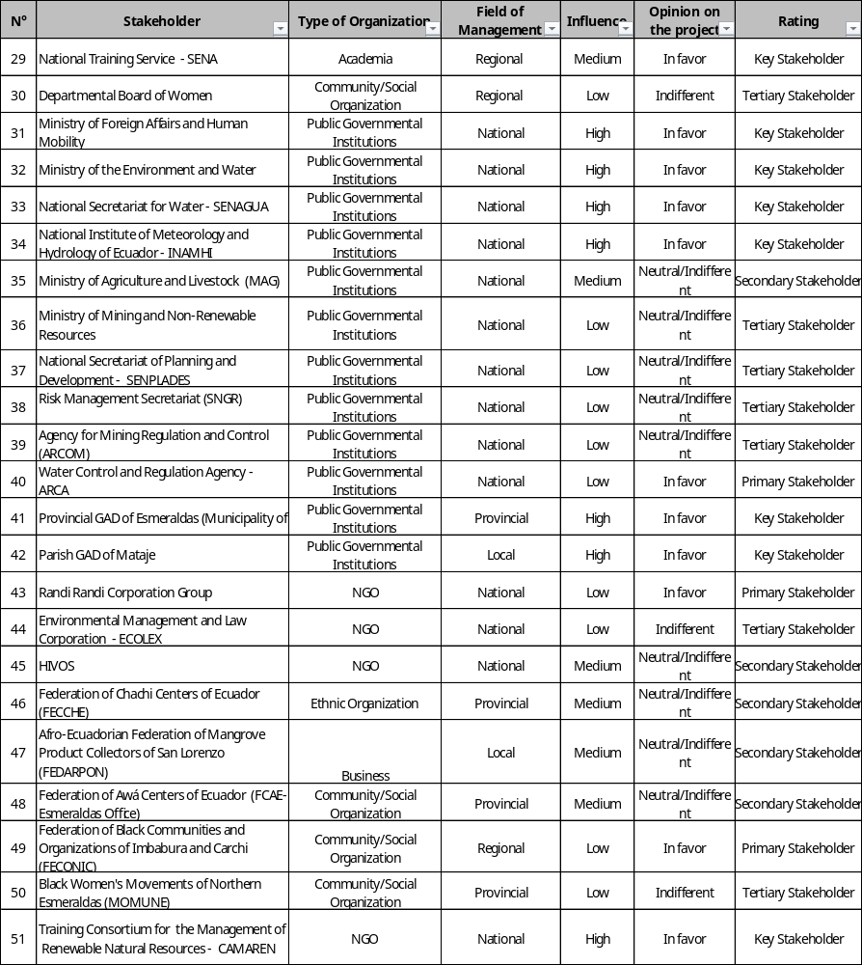

Exhibit 4. Stakeholders identified in the pilot treatment plant

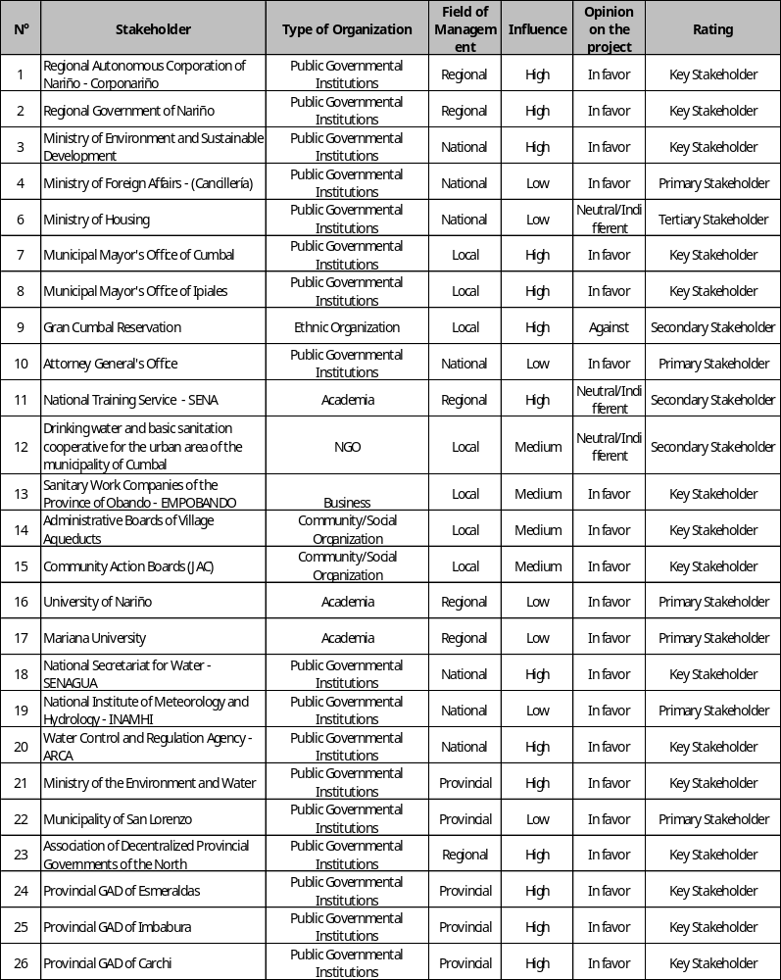

Continuation

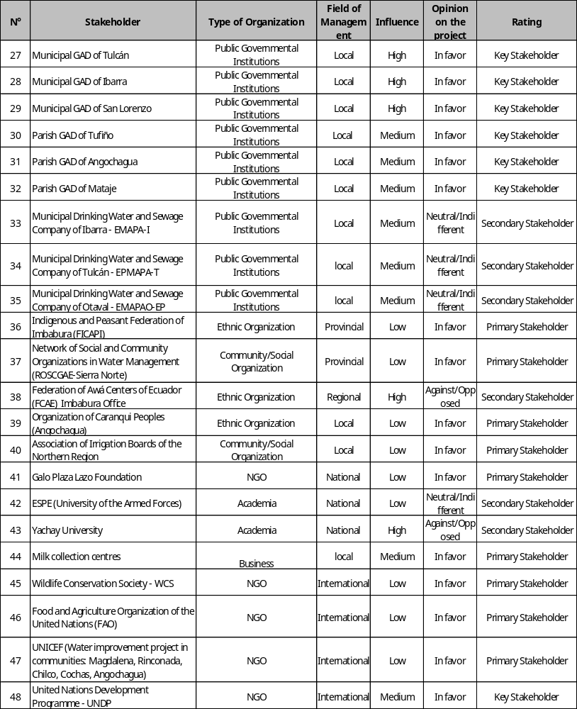

Exhibit 5. Stakeholders identified in the community Bio-engineering Work

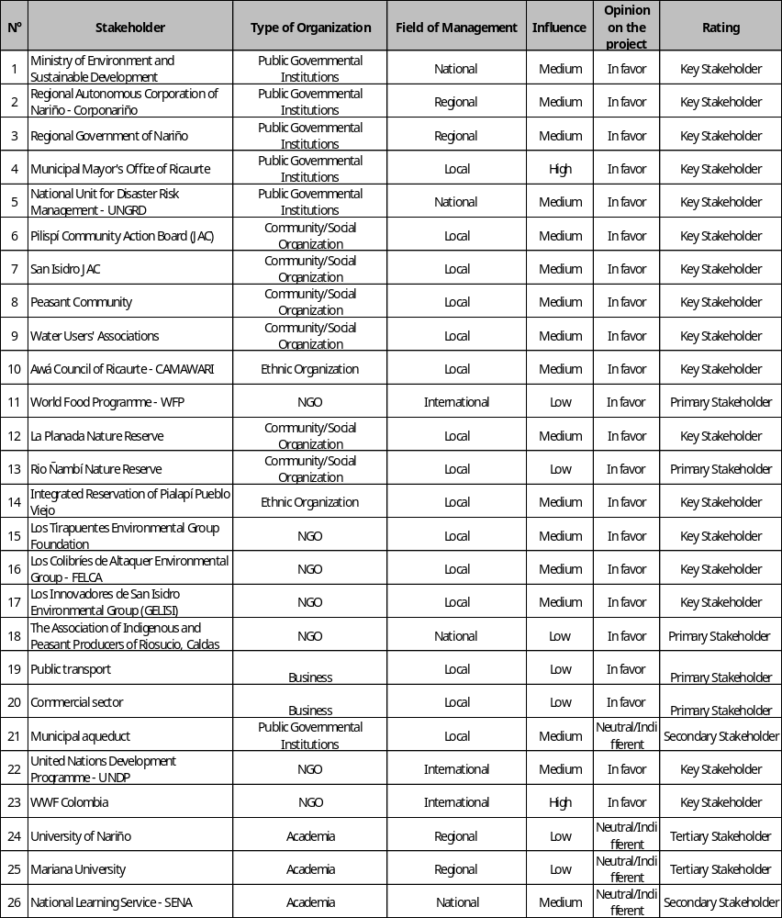

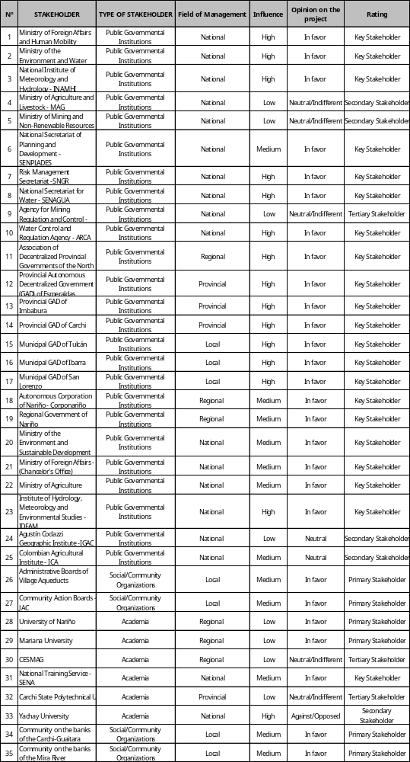
Exhibit 6. Stakeholders identified in the pilot Hydro-meteorological Network

Stakeholder Engagement Plan (SEP)

Yina Paola Pantoja Villota.
With contributions by Aracely Pazmiño Montero
CONTENTS

1 Summary 35
2. Introduction and description of the project 35
3. Legal Framework on Stakeholder Participation 37
3.1. International and National Legal Framework for Participation 37
3.2. GEF and UNDP Institutional framework on stakeholder integration 39
4. Summary of the stakeholder analysis 40
5. Summary of stakeholder participation activities prior to project implementation 42
Meeting with project partners 42
Binational meetings with project stakeholders 43
6. Stakeholder Engagement Plan 44
6.1 SEP Purpose and Scope 44
6.2 Description of the SEP strategies 45
6.3 Levels of Participation 47
6.4 Process for information dissemination 47
6.5 Resources and Responsibilities 48
7. Grievance Mechanism 49
8. Monitoring 53
9. Budget and responsibilities 54
Activity 55
Outcome 1: TDA Development 55
A consultant for support on participation and gender equality issues is integrated in the creation of the SAP Development Team. 55
Configuration of the team – contract of the communications specialist 55
Configuration of the team - local people to work with indigenous groups in Ecuador and Colombia 55
Concerning the consultation processes of views, goals and lines of SAP intervention, a process of information and consultation is carried out in local populations –where a specialist is hired to ensure adequate participation with a focus on gender and interculturality 55
Facilitation of spaces and/or meetings to work with indigenous communities 55
To implement the training course on hydro-diplomacy 55
To develop the training course on binational water school 55
To develop the training course on irrigation and drinking water boards 55
To make videos of the process (management of water basins and best practices of irrigation and drinking water boards) 56
Self-assessment and reflection meetings with the main stakeholders 56
Outcome 4.2: Knowledge 56
To develop the website of the project 56
To prepare communication and learning of the project 56
To publish de studies mentioned above (edition, diagramming, etc.). 56
Total SEP budget 56
11. Bibliography 56

1 Summary
The Stakeholder Engagement Plan (SEP) is a management tool designed to achieve the successful involvement and participation of stakeholders related to the water resource during the design and implementation of the "Integrated Water Resources Management of the Mira - Mataje and Carchi - Guaitara Binational Basins” Project, submitted to the GEF's international waters program by the governments of Colombia and Ecuador.

In its design stage, the stakeholders of pilot projects and the Mira and Mataje, Carchi-Guaitara basins were mapped in order to diagnose the engagement and participation conditions of the stakeholders in the project; various aspects of engagement were evidenced in integrated water resources management (IWRM).
The identification of stakeholders was not limited to listing only their institutional names but also to determine who these actors represents and make a rapid interpretation of the actions they perform, their role or roles, interests, significance and the influence they exert on the basins and other stakeholders. It was concluded that most of the identified stakeholders are grouped in public governmental institutions that have good relations among them and a favourable view of the project.
It was noted that although various public institutions are actively present in the three basins of the project, their activities have been stronger with the support of local NGOs and social community organizations in the Mira and Carchi-Guaitara basins. It is worth mentioning that a large number of stakeholders related to water were identified in different management levels without mechanisms for harmonization and participation.
This stakeholder engagement plan is developed to consolidate the project's social management, addressing the participation policies and rules of the GEF and UNDP, as well as the reference safeguards set internationally. This plan includes guidelines for the participation, engagement and communication of the different stakeholders that will be the reference frame for all processes associated with the project.

2. Introduction and description of the project

The Carchi-Guaitara, Mira and Mataje binational basins are the main water resources shared by Colombia and Ecuador in the Pacific Ocean basin (Figure 1). These resources are an important source of water, essential for socio-economic development and the integrity of ecosystems, which provide important ecological services locally and regionally.

Figure 1. Carchi-Guaitara, Mira and Mataje Binational Basins

Source: Análisis de situación y uso del recuro hídrico. Arévalo, and Rivera. 2019

Considering the strategic importance of cross-border basins, the governments of Colombia and Ecuador presented the "Integrated Water Resources Management of the Mira, Mataje and Carchi-Guaitara Binational Basins in Colombia-Ecuador” project. This project seeks to promote the Integrated Water Resources Management (IWRM) in these basins shared by the two countries, by strengthening the institutional and managerial capacities at the regional, local and community levels to achieve environmental and socio-economic benefits.
The project includes the components and results described below:

Component 1. Knowledge generation, information management and diagnostic analysis of the current state of transboundary water resources (surface and ground) of the Mira, Mataje and Carchi-Guaitara binational basins. The key product (Outcome 1) from this component is a Transboundary Diagnostic Analysis - TDA.

Component 2. Strategic planning to strengthen the governance of transboundary IWRM in the Mira – Mataje and Carchi-Guaitara bi-national watersheds and aquifers. A Strategic Action Program (SAP) will be developed and it is the key outcome (Outcome 2) from this component. It is the basis of binational ministerial agreements adopted by both countries on the priority actions to address the transboundary problems identified in the TDA of the basins under consideration.

Component 3. Capacity building at public, private and community levels enabling the shared IWRM of the basins of Mira-Mataje and Carchi-Guaitara rivers. The key (Outcome 3 - Training of key national and sub-national stakeholders in water resources management to strengthen the monitoring and control of water quality and availability).

Component 4. Innovative interventions for testing the socio-economic and environmental benefits from applying the IWRM at selected sites of the Mira, Mataje and Carchi-Guaitara binational basins. The following will be achieved:
- Outcome 4: (4) four innovative small-scale interventions in IWRM to ensure the provision of hydrological ecosystem services and sustainable livelihoods;
- Outcome 5: (2) Two prefeasibility studies on investments required for the transboundary IWRM in the Mira, Mataje, Carchi-Guaitara binational basins).

The main problems of the Mira, Mataje and Carchi-Guaitara basins identified in the Theory of Change (TOC) analysis of the project were the deterioration of water catchment and regulation ecosystems, water and soil pollution and degradation of soils and native vegetation. The root causes of these issues were identified as weak water governance, limited capacity to implement integrated water resources management and inadequate capacity of oversight and control. The binational basins under consideration lack the adequate mechanisms for the transboundary water management, and a limited engagement and participation of (institutional, community) stakeholders was identified. In addition, there is no clarity in the participation levels and governance mechanisms that enable participation.

Based on these facts, the objective of this Stakeholder Engagement Plan (hereinafter SEP) is to establish an iterative, participatory and inclusive process for the key stakeholders, throughout the project implementation. The SEP is primarily focused on strengthening the participation of stakeholders, especially those who depend directly on water for their livelihoods, in order to improve their quality of life through sustainable resource management and to establish governance mechanisms to reduce the key factors affecting the basin.

3. Legal Framework on Stakeholder Participation

3.1. International and National Legal Framework for Participation

To be able to talk about participation in integral water resources management, it is necessary to understand that participation is a fundamental human right and, as such, it should be an essential dimension of intercultural work under a gender equality perspective. Within this framework, this plan promotes the effective inclusion of the right to participation, which is contained in the main agreements, declarations and covenants of international law.

The Universal Declaration of Human Rights, adopted by the UN General Assembly on 10 December 1948, provides for the basic principles of human rights, including equality and non-discrimination; on the other hand, it establishes that citizen participation in decisions relating to their own development is a right and a responsibility.
International law has made important progress on the human, individual and collective rights of indigenous and tribal peoples since 1948. In the international realm, ILO Convention 169 of 1989 provided the first effective recognition of their rights. Prior to this, the UN Convention on the Elimination of All Forms of Racial Discrimination was approved by the General Assembly in 1965, and came into force in 1969; this Convention is based on the principles of the dignity and equality of all human beings, as well as recognizing that everyone has the same human rights and fundamental freedoms, without distinction based on race, language, sex, religion or nationality. Subsequently, the United Nations Declaration on the Rights of Indigenous Peoples, approved by the UN General Assembly in 2007, establishes a universal framework of minimum standards for the survival, dignity, well-being and rights of the indigenous peoples of the world, recognizes collective rights, including on the territory and natural resources and also condemns discrimination against indigenous peoples and promotes their full and effective participation in all matters that concern them. For its part, the Inter-American Commission on Human Rights (IACHR) and the Inter-American Court of Human Rights have been working, mainly since this millennium, to set important standards regarding the rights of indigenous peoples in the Americas, such as for example, regarding the interpretation of the right to collective property and protection of the natural resources of indigenous peoples.
Colombia adopted these Declarations, through the recognition of the democratic and participatory character set by the Social Rule of Law in the 1991 Constitution to facilitate the participation of all citizens in the decisions that affect them and provide the possibility to intervene actively in the control of public management (Articles 2 and 40); similarly, it determined how citizens participate in the planning, follow-up and monitoring of the State management outcomes (Article 270). On the other hand, the State recognizes and protects ethnic and cultural diversity and fosters the participation of representatives from the respective communities when (legislative and administrative) measures are taken or when projects, civil works or activities are to be carried out within their territories (Articles 7 and (paragraph 330)); under this context, the right to Free, Prior and Informed Consultation (FPIC) must be exercised, and this is a right and an instrument for participation in the decisions on all matters concerning indigenous peoples.
In this sense, the FPIC procedure will be implemented under the rules set forth in international agreements and the national legislation, including the verification of the National State in charge of ensuring and enforcing the rights of indigenous communities. For this purpose, dialogue spaces are provided to discuss and analyse when, how and under what situations FPIC should apply, as well as, define and agree on a path for its implementation.

Concerning the issue of water resources related to the project, Decree 1640/2012 in Article 30 states that "the participation strategy should identify the natural, legal, public and private persons, as well as the ethnic communities settled in the water basin, and define the process to form the Basin Councils". On the other hand, Article 50 mentions that "natural, legal, public and private persons settled in the water basin declared under management by the relevant environmental authority may participate in the different phases of the land-use process and management of such basin, submitting their recommendations and observations through their representatives".
In the case of Ecuador, in the field of Human Rights, the Ecuadorian Constitution of 2008 establishes in Article 61 the right to participation as the right to "elect and be elected, participate in public affairs, submit projects of popular initiative for legislation, be consulted and oversee the actors of public power". In the context of the Duty of Transparency and Social Control, Article 207 states that “The Council of Citizen Participation and Social Control will promote and encourage the exercise of rights relating to citizen participation, promote and establish mechanisms of social control in matters of public interest”.
The Organic Law of Citizen Participation (Law 13 of 2010) aims to promote, encourage and ensure that the rights of citizen participation are exercised in a leading role in public decision making, including; institute instances, mechanisms, instruments and procedures for public deliberation between the State, across its different levels of government, and society.
In turn, the Organic Law on Water Resources, Uses and Exploitation of Water (2014) in article 36 reads "The State and its institutions within its sphere of competence are responsible for the integrated management of water resources in a water basin. Therefore, they are subject to: Promote and strengthen the participation of user organizations and consumers of public and community water systems in water management activities, through the water basin councils and the Intercultural and Plurinational Water Council".

3.2. GEF and UNDP Institutional framework on stakeholder integration
The participation of stakeholders is vital to the success of projects financed by the Global Environment Facility - GEF because it can improve their performance, as it allows a better design and execution of funded activities by reducing risks and considering the social and economic needs of impacted parties. The Policy on Stakeholder Participation establishes the basic principles and mandatory requirements for their participation in management and operations of the GEF to promote transparency, accountability, integrity, effective participation and inclusion. The Policy ensures projects follow a constructive, responsive, accountable and transparent participation of stakeholders to support the fair, balanced and inclusive engagement in management and operations of the GEF (GEF, 2017).

Regarding the GEF-financed activities, the Policy reaffirms and enforces the GEF's commitment "to allow free access to any information that is not confidential, as well as, consulting the main groups and local communities throughout the project cycle, so that they participate when appropriate". To be effective and meaningful, stakeholder participation requires constant commitment and action by the interested parties –including the proper allocation of resources– throughout the process of identification, design, implementation, monitoring and evaluation of activities funded by the GEF (GEF, 2017).

In addition, the UNDP is committed to ensuring the meaningful, effective and informed participation of key stakeholders in the development and implementation of their programs and projects, guidelines and guidance provided by the SES (Social and Environmental Standards) (UNDP, s/f). The engagement of these stakeholders seeks to identify their priorities and give them opportunities to express their views at any time during the decision-making process concerning matters that affect them directly; additionally, they will allow project teams to consider and respond to such matters. This is an ongoing process that may involve various elements at different levels, for example: analysis and planning of key stakeholders; disclosure and dissemination of information; consultation and meaningful participation; dispute resolution and redress of grievances; constant submission of reports to communities and impacted stakeholders, and their inclusion in the monitoring and evaluation processes (UNDP, 2014). Likewise, the UNDP Strategic Plan 2018-2021 is based on the 2030 Agenda for Sustainable Development and assumes the commitment to the principles of universality, equality and leaving no one behind.

The participation process of Indigenous Peoples is based on the practices and recommendations of the Global Environment Facility - GEF and the United Nations Development Program - UNDP; such participation is planned specifically as a process of intercultural, responsible, inclusive and transparent dialogue under the guidelines of the "Policy on Stakeholder Participation" and the "Minimum Standards on Environmental and Social Safeguards" of the GEF. Similarly, the guidelines and guidance provided by the SES (Social and Environmental Standards) of the UNDP are also considered. Furthermore, under Convention 169 ratified by Colombia, the national government will ensure the free, prior and informed consent of Indigenous Peoples.

4. Summary of the stakeholder analysis
For an adequate design and implementation of the project with a participatory and inclusive approach of key stakeholders, following the GEF and UNDP policies and guidelines, stakeholders were initially identified via a map-based analysis.

The identification of actors was made based on the characterization of the sectors in which the State is organized, and the role played by the actors (institutional, economic, social, academic and community) in the integral management of water resources in the Carchi -Guitara, Mira and Mataje watersheds. Stakeholder identification was carried out by characterizing the sectors where the State structure is present and the role played by the actors (institutional, economic, social, academic and community) in integrated water resources management at the Carchi-Guaitara, Mira and Mataje basins. Stakeholders were analysed considering their influence and view on the project; this allowed the classification of the institutions and organizations involved in the process by gaining an understanding of their ties, interests, positions, as well as the people who represent the stakeholder groups, identification of the stakeholders that may cause conflicts and who the losers and winners are under different circumstances.

Within this framework, stakeholder analysis not only contributed to gain a clear idea of groups that are present in the basins, but also helped identify the leadership exercised in water management activities and their willingness to participate in collaborative efforts. It also allowed the identification of the “Key Stakeholders" and build –what would be considered– the social base of support for this project. In total, 96, 62 and 53 stakeholders were identified for Mira, Carchi-Guaitara and Mataje basins, respectively. Most stakeholders have been located together in public governmental institutions.

Most of the identified stakeholders have a favourable view of the project, but their levels of influence can vary among them to some extent; this is important since the levels of influence ranges from high to average, suggesting that there is leadership, skills for calling, management and legitimacy among the main stakeholders, and many of them have a visible presence and impact in the territory. Therefore, this suggests strong interest and involvement in the management and networking for basin governance.

The favourable view of the project is mainly given by stakeholders that comes from public institutions, specially at the Carchi-Guaitara and Mira basins; a significant participation of municipal, departmental and provincial territorial entities was also observed, namely: CORPONARIÑO, Nariño Governor’s Office, Provincial GADs (Decentralized Autonomous Governments), entities and institutions that have a positive relationship with each other.

There is also high representation of NGOs in the basins, across all management levels; these organizations focus on the promotion and development of communities and the defence of collective interests. They are able to generate learning, innovative and feasible project proposals, and their successful execution necessarily requires the ability to interact and influence other stakeholders to achieve common purposes.

On the other hand, there are ethnic communities or indigenous peoples, most of which are grouped in what it is called “second-level organizations” which integrates unions, federations, etc. It is these groups that stated they currently do not support the project. This information is derived mainly from Colombia, where the main concern relates to the importance of performing the due process of consultation following the principle of free, prior and informed consent.

Finally, there are some social and community organizations that fulfil important roles in their communities by promoting community development and acting as a meeting point for any project or activity and the communities they represent. They are also able to integrate isolated individuals and groups into social order, through the structuring of a collective process of "Social Capital” construction. This is an additional factor that explains the role of civil society in the process of governance construction, as it provides an important link to understand the role of the community action boards, the aqueduct boards and associations of irrigators as potential engines of transformation.

Consequently, the stakeholder analysis identified in the Carchi-Guaitara, Mira and Mataje basins (See Annex 1-3 detail of stakeholders per basin) and in the pilot projects (see Annex 4- 6) eight groups of key stakeholders that come together in the following two groups:

- Government Entities
- Entities and institutes directly linked to integral water resources management: Stakeholders who guide the process of policy making, regulate the general conditions for knowledge, conservation and sustainable use of biodiversity and set of guidelines for the development and management of water basins.
- Entities in charge of international negotiations: National institutions directing international policy and responsible for its management and coordination.
- Territorial entities and sub-national entities: Entities in charge of promoting, implementing and adopting national, regional and provincial programs and policies related to the water resource.

- Organizational Stakeholders
- Cooperation organizations: Decentralized organizations that work with governments and citizens in the search for human development solutions and promote the development of sustainable and resilient territories as a factor of peace-building, poverty mitigation and wellness generation for the population.
- Non-Governmental Organizations (NGOs): There are a number of non-governmental organizations that focus mainly on the promotion and development of the community and the defence of collective interests.
- Social community organization: Groups formed by inhabitants of a parish, municipality, canton, etc. to exercise their rights, make progress in self-management, and defend and promote common interests.
- Organizations of indigenous peoples and Afro-descendants: Ethnic groups or groups of indigenous peoples recognized by the State with special rights in a territory, i.e. the indigenous territories and collective territories of black communities or Afro-Colombian communities.
- Academia: They are stakeholders such as universities and educational institutions that perform training, research and/or environmental studies at the basin.

5. Summary of stakeholder participation activities prior to project implementation
The design process of the project was conducted during eight months in which several meetings were held with the stakeholders related to the basins under study and the institutions that would take part in its future implementation. The following is a summary of information, socialization and construction activities of the project:

Meeting with project partners
Three meetings were held with partners (Table 1) during the first steps of the Project Preparation Grant (PPG) start-up phase.
Table 1. PPG Meetings with partners
Date | Place | Objective | Outcomes | Participants
July 26 and 27, 2018 | Pasto - COL | To analyse the PIF elements and establish the necessary roadmap and agreements for the PPG preparation phase". | The organizational arrangements for the PPG implementation were set. For example, they are:  Essential agreements were established for the PRODOC development (intervention sites for pilots, projects with pre-feasibility studies, key stakeholders involved in the PPG).  A review and initial validation were conducted on the actions to be executed in the project | MADS, Ministry of Environment and Water, IDEAM, SENAGUA, Ministry of Foreign Affairs (Chancellery), MAE Carchi, Nariño Governor's Office, -CORPONARIÑO, GAD, Prefecture of Imbabura, Prefecture of Carchi, Prefecture of Esmeraldas, Mancomunidad del Norte, UNDP-Colombia, UNDP Ecuador, UNDP-RSC LAC.
December 4 and 5, 2018 | Quito - EC | To check the structural elements of the project document. | The structural elements of the project document were set (results framework, budget, work plan, implementation arrangements, co-financing, host country).  The roadmap for the PRODOC review was agreed and submitted to the GEF. | MADS, Ministry of Environment and Water, IDEAM, SENAGUA, Ministry of Foreign Affairs (Chancellery), MAE Carchi, Nariño Governor's Office, -CORPONARIÑO, GAD, Prefecture of Imbabura, Prefecture of Carchi, Prefecture of Esmeraldas, Mancomunidad del Norte, UNDP-Colombia, UNDP Ecuador, UNDP-RSC LAC, WWF Colombia
January 29 and 30, 2019 | Ipiales - COL | Review of the PRODOC draft | The PRODOC draft to be submitted to the UNDP review process and subsequently for GEF consideration was agreed.  The roadmap for the pending tasks to submit the PRODOC to the GEF was agreed. | MADS, Ministry of Environment and Water, IDEAM, SENAGUA, Ministry of Foreign Affairs (Chancellery), MAE Carchi, Nariño Governor's Office, -CORPONARIÑO, GAD, Prefecture of Imbabura, Prefecture of Carchi, Prefecture of Esmeraldas, Mancomunidad del Norte, UNDP-Colombia, UNDP Ecuador, UNDP-RSC LAC, WWF Colombia

Binational meetings with project stakeholders
In the framework of the project preparation process, there were five meetings with key stakeholders of the project water basins from both countries (Table 2).

Table 2. Meetings with key stakeholders of the Project
Date | Place | Objective | Results | Participants
September 10, 2018 | Pasto-  COL | To the project and contact its related stakeholders | The GEF Mira, Mataje and Carchi-Guaitara Binational Basins project was socialized.  Contact was established with key stakeholders related to the project. | Governors and leaders of the Pastos Indigenous People (Carchi-Guaitara).
September 21, 2018 | Ibarra - ECU | To begin the project preparation process and contact its related stakeholders. | Contact was established with key stakeholders related to the project.  A review and initial validation were conducted on the actions to be executed in the project. | Local key stakeholders related to the project.  Focal points of the project partners.  GEF focal point in each country
September 28, 2018 | Pasto-  COL | To socialize the project and contact its related stakeholders | The GEF Mira, Mataje and Carchi-Guaitara Binational Basins project was socialized.  Contact was established with key stakeholders related to the project. | UNIPA
October 25 | Tumaco -  COL | To socialize the project and contact its related stakeholders | The GEF Mira, Mataje and Carchi-Guaitara Binational Basins project was socialized.  Contact was established with key stakeholders related to the project. | Bajo Mira y Frontera Community Council  Natural National Parks
November 21, 2018 | Ipiales - COL | To validate the proposals for action of the project | Theory of Change with comments and contributions of the key stakeholders.  Final elements that integrate the outcome framework of project.  Validation of co-funding contributions | Local key stakeholders related to the project.  Focal points of the project partners.  GEF focal point in each country

6. Stakeholder Engagement Plan

6.1 SEP Purpose and Scope

The Stakeholder Engagement Plan (SEP) is a management tool designed to achieve the successful involvement and participation of stakeholders related to the design and implementation of the "Integrated Water Resources Management of the Mira-Mataje and Carchi-Guaitara Binational Basins” Project (the Project), submitted to the GEF's international waters program by the governments of Colombia and Ecuador.

The SEP will establish effective mechanisms of coordination among organizations and government levels in the project implementation, so that they affect positively Integrated Water Resources Management of transboundary basins.

SEP Objectives
1. To ensure the effective engagement of all key stakeholders in project implementation, as well as the inclusion and distribution of benefits.
2. To identify spaces and times for participation and consultation to be performed during the project implementation; also, to identify mechanisms of prior consultation to be used.

6.2 Description of the SEP strategies
The SEP recognizes the different capabilities, levels of organization, representation and articulation of the stakeholders involved in the Project, and it takes into account that to this date both countries show progress in initiatives for IWRM in the Carchi-Guaitara, Mira and Mataje transboundary basins. For this reason, the SEP promotes effective and meaningful participation in the cycle of its design and implementation, and includes the appropriate actions for inclusion and distribution of project benefits, thus the following guidelines are suggested:

Strategic Actions of the SEP
- Professionals specialized in participation are integrated into the project team to ensure that implementation has suitable technical support for the execution of activities.
- Specialists in participation, gender and interculturality are recruited, as well as a communications professional to perform specific studies of social integration and establish mechanisms for the project stakeholders to communicate and collaborate. They will also work on the collection and organization of information including capturing key lessons learned.
- A specialist in participation and gender equality is hired to ensure the engagement of the various stakeholders, communicate the TDA results and support local activities of consultation and participation of the SAP.
- Local people are hired to work with Awá, Pastos and Afro-descendant indigenous and ethnic communities, in order to ensure a positive relationship with the stakeholders and strengthen actions in the basins.
- The TDA development team must include at least 30% of people from non-government organizations to ensure participation and inclusion of the stakeholders in the project components.
- The SAP development team must include representatives of grassroot organizations nominated by the SAP team, in order to ensure participation and inclusion of the stakeholders in the project components.
- Different participation spaces are enabled: including workshops, meetings and training for the development of the TDA/SAP process that will be provided by specialized professionals under a pedagogical framework for each process and audience, that considers intersectional perspectives and participation tools.
- Different information and consultation meetings are developed in each basin, focusing on stakeholder diversity; these spaces are provided with suitable and specialized personnel for each theme to be addressed and their contents will have a pedagogical ludic strategy that responds to the needs and level of knowledge of each audience.
- From a perspective of human rights and fundamental freedoms of the indigenous peoples of Colombia, different spaces are enabled for dialogue and consultation with the Pastos and Awá Indigenous Peoples.
- Intercommunication channels are set for mutual transmission of information, knowledge and experiences of the project, using different methods of participation such as: correspondence via e-mail/telephone, meetings, workshops, web page, videos, reports and learning documents, etc.
- The necessary mechanisms are provided to ensure the adequate incorporation of comments, visions, needs and concerns of the stakeholders involved in the project.
- The strategic actions detailed above are included in the Project results framework along with their respective indicators.

6.3 Levels of Participation

After identifying the strategic actions that will be incorporate to this plan, the various involvement mechanisms the project will require are presented below:

a) Reporting: to enable stakeholders understand the situation, developed processes, different alternatives and their implications. It is a one-way communication.
b) Training: to meet the knowledge demands of key stakeholders on more specific topics (TDA/SAP workshops, training course on water governance, hydro-diplomacy, gender and government, etc.) and to strengthen their capabilities and expand their degree of understanding and action on the topic.
c) Consulting: to obtain feedback of stakeholders on situations, alternatives, scenarios and decisions. It is a two-way communication. It allows considering their interests, priorities, needs and concerns.
d) Engaging: It includes a mechanism to integrate relevant stakeholders at different project stages to generate open and participatory processes that allow including their comments, needs and/or contributions.
e) Decision-making: It is the top level of integration; the aim is for actors to be able to make informed decisions on the processes developed in the project framework.
As shown in detail in Table 8 (SEP Summary), the proposal is to work with actors in all levels of participation; it also suggests which stakeholders should participate in those workspaces defined by the Plan as priorities. Initially, it suggests a group of relevant stakeholders who will sit at the table, or in multiple tables, in the first Consultation with indigenous peoples.

6.4 Process for information dissemination
To guarantee and ensure the effective participation of stakeholders, observing the rights and access to information of all parties involved, the stakeholders and partners of the project will work jointly and continuously with the communication specialist and participation specialist/facilitator hired by the project, to collect, consult and disseminate project information and encourage relevant inputs and active participation from stakeholders in different spaces of dialogue. In all cases requiring the transmission of information to the various stakeholders, the content will be adapted through culturally appropriate means.
The following is a list of the methods that will be used to disseminate information about the project.
- Correspondence via e-mail / phone: To distribute project information to the partners and stakeholders of the project and inform the concerned interested parties about the meetings, consultations, workshops, etc.

- Communication via print media - newsletters - documents: The documents to disseminate project information will be in a format accessible to the general public (visually attractive, simple language and pedagogically appropriate to the interest groups). Such documents will include summaries in Spanish, Awá Pit, Quechua and English languages. They will be in high quality for web browsing and downloading.

- Video: Videos with the project achievements and lessons learned, including the testimonies of the main stakeholders and beneficiaries, will be available through IW: LEARN, the websites of project partners and via the Project´s YouTube channel.

- Website: To develop the project website under the IW guidelines: LEARN, web portals linked to the project partners.

- Technical documents: Documents containing organized and structured information about the project presented effectively.

- Individual interviews: To build personal relationships with the interested parties, request opinions (recorded interviews).
- Formal meetings: To build relationships with the project partners, distribute technical documents and present information using PowerPoint. To make use of the discussion summary, comments / questions and answers.

- Public meetings: To build relationships with local communities, present information to a wide audience of interested parties or a particular community using PowerPoint, video, or distributing non-technical information of the project. To make use of the discussion summary, comments / questions and answers. The contents of these meetings will be delivered to the audience once they have been adapted through a pedagogical mediation process.

- Focus group meetings: To facilitate the meeting in smaller groups from 8 to 15 people who contribute with their points of view and provide opinions about the project. To make use of the discussion summary, comments / questions and answers. The contents of these meetings will be delivered to the audience once they have been adapted through a pedagogical mediation process.

- Workshops: To present the project information before a group of key stakeholders, use participatory exercises to facilitate group discussions, exchange ideas, analyse information and develop recommendations and strategies. To make use of the discussion summary, comments / questions and answers. The contents of these meetings will be delivered to the participants once they have been adapted through a pedagogical mediation process.

- Visit to the site: To collect opinions from individual stakeholders by visiting the basins.

6.5 Resources and Responsibilities
The group in charge of implementing the specific stakeholder participation activities will be the project implementation unit that will be supervised and hired by the implementing partner: The United Nations Development Program - UNDP (Ecuador and/or Colombia) and implementing partners of the project: Ministry of Environment and Sustainable Development – MADS (Colombia) and the National Water Secretariat – SENAGUA (Ecuador).

7. Grievance Mechanism
This plan has been integrated –in accordance with the UNDP policies and environmental and social safeguards (SES)– a response mechanism for the concerned interested parties or a mechanism of claim response to guarantee that persons, indigenous peoples and communities impacted by projects have access to adequate procedures for claim resolution to listen to and address complaints and disputes related to the project.
Therefore, according to the Response Mechanism for the UNDP stakeholders, "a mechanism of claim response has been designed to complement the proactive participation of the project stakeholders and implementing partners throughout the project cycle. This effective participation of local stakeholders creates opportunities to solve problems that would otherwise lead to conflict. If they are not solved, major problems may emerge, generating conflicts that delay a project, increase costs and, sometimes, stop the project".

In this context, any person or group of people who believe they are negatively affected by the project, or at risk of adverse impacts, may file a claim .

It is also worth mentioning that complaints or claims can be received that are not necessarily within the competence of the project, the partners or the UNDP and GEF agencies. Therefore, a mechanism has been designed that integrates various levels for the reception, evaluation and management of solutions on the claims or complaints that arise and that fall within the scope of the project.
Levels of reception and claim reparation procedure: The procedure consists of four levels (see Figure 2), which should resolve the submitted claims and –based on the difficulty or complexity of its resolution or reparation– escalate to the next decision-making instance of the project until the Board of Directors is reached.

Figure 2. Levels of complaint

The following is detailed in each of the levels:

1st level: reception of the claims: The difficulties or claims must be presented through two channels:

A) Through the Community workers (in written form).
- It will be a function of the community workers, acting as a key point of contact to receive the concerns and / or claims of the project.
- Claims must be made in writing and signed and dated by the people or communities affected by the project.
- Claims received verbally must be documented, verified and signed by the people or communities affected by the project, so that the local facilitator can give due process.
- The local facilitator will establish a record of all claims received and this record of complaints must specify the name of the persons or communities affected by the project, the reason for the claim and the date of receipt. The local facilitator will issue the acknowledgment of receipt of the claim for the persons or communities affected by the project in writing, within 2 business days.

B) Through written communications submitted to the project's governing bodies through the means established for this purpose (email of the gender and participation specialist, the binational coordinator, or an email from a UNDP delegate official (who is linked to the execution of the project) or in a space generated on the website of the project etc.). This is given in case the complaints are minor or have not been addressed by the community workers. This presentation mechanism can also be used in case the claim has to do with the receivers of the claims (Community workers) or there has been a dispute involving them.

In any case (either A or B), the complaint is received in written form by the EGP person.

2nd level: The person in charge of Gender, participation and intercultural specialist (EGP) receives the corresponding claims presented through a written communication.

- At this level, the person in charge receives and evaluates the type of claim presented.
- In this instance, they must provide a written acknowledgment of receipt within 3 business days of receiving the request and indicate that they will complete the review within 15 business days of receipt of the claim.
- If the application is incomplete, it must be returned to the applicant within 3 business days of receipt, with a clearly specified request to provide the missing information.
- In all claims, an answer of eligibility or no of the same one is offered.
- In all cases, the EGP must monitor said action at a later date, and report periodically to the claims repair committee (CRR).
In case of not being able to provide an appropriate response, the claim must be followed to the next level of decision making.

3rd level: The person acting as binational Project Coordinator - or Project Coordinator receives the claims presented through the EGP that could not be managed or solved.

In addition, complaints can be received directly through electronic means designed for this purpose (email, website of the project, others).

4th level: Project Claims Reparation Committee (CRR): This body receives complaints that project personnel have not been able to solve or manage since they were received. It is not a permanent committee, but it is activated once claims are received to be served at this level; since only those claims that involve risks to the beneficiaries and their rights, or they can represent potential significant risks for the execution will arrive to this committee

- The project's board of directors establishes the CRR, which will be chaired by the bi-national project coordinator. It will be responsible for receiving and resolving, in a fair, objective and constructive way, complaints raised by the people or communities affected by the project that involve risks important for its execution, but especially those that put at risk the beneficiaries and partners, or their rights.
- The CRR must be chosen at the beginning of the execution of the project.
- The CRR must be informed periodically about the minor claims cases that the staff has solved.
- It is part of the function of the CRR to disclose the claims management procedures in addition to monitoring and evaluating compliance with the agreements reached through the mechanism for repairing claims.
- When a resolution is not reached at the CRR level, or if the people or communities affected by the project do not receive a response or are not satisfied with the result within the agreed time, they can appeal to the Project Board.

Claim Resolution Steps

Step 1: Response
Once the action to resolve the submitted claim has been identified, the response must be communicated to the applicant within 15 days.
The response should be recorded as part of the reports on the grievance mechanism.
The response must be in writing, in a language that is easily accessible to those who have requested it. This must be done at the level of solution that has been made at the level of EGP, binational coordinator or CRR.

Step 2: Meeting
Should be scheduled in order to review and present the response to the complaint. Whatever the answer, it is essential that applicants fully understand both the proposed response and the options they can take after considering the proposed response.

Step 3: Action
When there is an agreement between an applicant and the project to move forward with the proposed action, or a process of direct dialogue or relatively simple negotiation, then that action must be implemented.

Step 4: Monitoring
It must be monitored to ensure that the response solves the problems raised by the applicant.

Closure of the claim
The last step is to close the process. If the response and the action taken has been successful, the satisfactory resolution must be documented. In cases where there have been significant risks, impacts and / or negative publicity, it may be appropriate to include written documentation from the applicant that indicates satisfaction with the response that was made to the claim. In regular cases that did not require major efforts, or were claims resolved in the first instance, the measures must be recorded, and the response should have been satisfactory for the applicant. In situations of more complex and unusual complaints, it may be useful to document the key lessons learned.

In case of lack of agreements
In some cases, it may not be possible to reach an agreement with the applicant about the response proposed by the project. In a multi-stakeholder dispute, an evaluation process may lead to the conclusion that a collaborative process is not feasible. If a collaborative process is used, good faith efforts may still not be able to solve the key problems.
In any of these situations, the process and pending issues with the requesting person, the project staff, the CRR committee and any other relevant interested party, should be reviewed to see if a modification of the response could satisfy all of their interests and concerns.

If no modification to the answer is mutually acceptable, the applicant can look for other options within the national legal and administrative systems. Whichever alternative the petitioner of the complaint chooses, it is important that the project staff document their discussion with the applicant and the final choice of that person.

8. Monitoring
This stage seeks to document and systematize the participation process, as well as communicate how the contributions of different stakeholders in each stage of the process have been managed and used, while providing a valuable input to mitigate risks or impacts to assess the progress made and potential improvements to be applied in subsequent phases of the project.
Within the framework of this SEP, clear mechanisms of monitoring that allow effective evaluation of the generated outcomes have been proposed, including the following items:
- To review, analyse and systematize the contributions made by stakeholders in each participation method suggested in this plan.
- To document the processes carried out, as well as the results obtained, so that they are published and disseminated. (Memory cards, minutes, participation lists, reports, systematization documents of the different stages, outcomes, potential risks, agreements and disagreements, etc.)
- To evaluate the different stages on the participation processes by conducting surveys that allows measuring the level of acceptance, comprehension, and progress.

Reports to stakeholders: Informing the concerned stakeholders implies providing important details about the commitments, routines, status and progress of the project. This part also includes new or corrected information since the last report. To monitor the commitments acquired with different stakeholders at different times. The methods and frequency of reporting to stakeholders ​​are provided below.

Table 9. Methods and frequency of reporting to stakeholders
Reporting party | Reporting method | Stakeholder | Information | Frequency
Executing Partner  Implementing Partner | Formal meetings | Partners | Project Status  Planning for the next term.  Problems and changes. | Semi-annual meeting
Partners  Executing Partner  Implementing Partner | Public Meetings | Entities directly related to IWRM  Territorial and Sub-National Entities  Cooperation Organizations  NGOs  Social Community Organization  Organizations of indigenous peoples and Afro-descendants  Academia | Project progress  Planning for the next term.  Problems and changes. | Semi-annual meeting
Partners  Executing Partner  Implementing Partner | Printed media  Website |  | Project progress  Problems and changes. | When changes occur

9. Budget and responsibilities
The main actors in charge of ensuring compliance with the SEP activities in the highest instance are the implementing partner, UNDP and the executing partners of the project: Ministry of Environment and Sustainable Development - MADS and the National Water Secretariat - SENAGUA.
The actors responsible for SEP implementation are, the Binational Coordinator in their capacity as project coordinator and, the gender, participation, and intercultural specialist (EGP), with the support of the SAP participation and gender equality assistant. As a project team they are responsible for ensuring the successful execution of the planned activities.
This plan details two types of activities; one type requires a specific budget for its implementation (Plan Summary); and the other type are design actions that are described so that they are developed, but do not require a budget for their implementation, for example, the inclusion of minimum participation percentages, progress and evaluation reports, the different stages of the participation processes, among others.
The activities that require a budget are presented below:

Activity | Budget $ USD

Outcome 1: TDA Development
Configuration of the team – contract of a specialist in participation and gender equality | 22,954
Configuration of the team – contract of the communications specialist | 24,023
Collection and organization of existing information on issues related to participation that contribute to the description of social information from the basins under study. | 7,000
Integration of the basic studies on issues of gender and participation in the basins under study: (a) Study on the governance of water and irrigation boards with a focus on gender and intercultural analysis; (b) research on success stories. | 25,000
Training workshops on:  TDA/SAP methodology  Introduction to TDA  To validate the analysis of the causal chain and the SAP link | 31,480
Outcome 2: SAP Development
A consultant for support on participation and gender equality issues is integrated in the creation of the SAP Development Team. | 32,135
Configuration of the team – contract of the communications specialist | 14,526
Configuration of the team - local people to work with indigenous groups in Ecuador and Colombia | 56,000
Concerning the consultation processes of views, goals and lines of SAP intervention, a process of information and consultation is carried out in local populations –where a specialist is hired to ensure adequate participation with a focus on gender and interculturality | 27,200
Facilitation of spaces and/or meetings to work with indigenous communities | 70,000
Outcome 3: Training
To implement the training course on hydro-diplomacy | 20,000
To develop the training course on binational water school | 70,000
To develop the training course on irrigation and drinking water boards | 30,000
To make videos of the process (management of water basins and best practices of irrigation and drinking water boards) | 5,000
Outcome 4.1: Pilot Projects
Self-assessment and reflection meetings with the main stakeholders | 18,000

Outcome 4.2: Knowledge
To develop the website of the project | 5,000
To prepare communication and learning of the project  To publish de studies mentioned above (edition, diagramming, etc.). | 29,000
Total SEP budget | 487,318

11. Bibliography

Análisis de actores en las cuencas Carchi - Guáitara, Mira y Mataje

Constitución de la República del Ecuador Asamblea Constituyente, 2008
http://www.derecho-ambiental.org/Derecho/Legislacion/Constitucion_Asamblea_Ecuador_5.html

Constitución política de Colombia. 1991. http://www.ramajudicial.gov.co/documents/10228/1547471/CONSTITUCION-Interiores.pdf

International Convention on the Elimination of All Forms of Racial Discrimination. 1965

Organización Internacional del Trabajo (OIT). 1989. Convenio 169, Sobre pueblos indígenas y tribales en países independientes. http://www.refworrld.org.es/docid/50ab8efa2.html

Declaration of Indigenous Peoples of the Organization of the United Nations. 2007

Decreto 1640 del 2012. Instrumentos para la planificación, ordenación y manejo de las cuencas hidrográficas y acuíferos

Law 13 of 2010. Organic Law of Citizen Participation of Ecuador. 2010

Ley Orgánica de recursos hídricos, usos y aprovechamiento del agua (2014) Colombia

Programa de las Naciones Unidas para el Desarrollo (PNUD). 2014. Estándares Sociales y Ambientales. http://www.undp.org/content/undp/en/home/librarypage/operations1/undp-social-and-environmental-standards/

Programa de las Naciones Unidas para el Desarrollo (PNUD). 2018. Ayuda Memoria del Taller binacional de inicio de la Preparación del Documento del Proyecto (PPG). Friday, September 21, 2018. Ecuador

Strategic Plan of the United Nations Development Program 2018-2021

GEF. 2017. Política sobre participación de los interesados

UNDP 2018. Strategic Plan 2018-2021

UNDP. (2017). Guidance notes. UNDP Social and Environmental Standards. Standard 6: Indigenous Peoples. https://info.undp.org/sites/bpps/SES_Toolkit/SES%20Document%20Library/Uploaded%20October%202016/Final%20UNDP%20SES%20Indigenous%20Peoples%20GN_Jan2017.pdf

UNDP. (2014). Stakeholders Response mechanism: Overview and Guidance.
http://www.undp.org/content/dam/undp/library/corporate/Social-and-Environmental-Policies-and-Procedures/SRM%20Guidance%20Note%20r4.pdf

UNDP. (s/f). Social and Environmental Standards: Stakeholder Engagement Plan.

Annex 1. Key Stakeholders of the Carchi-Guaitara Basin
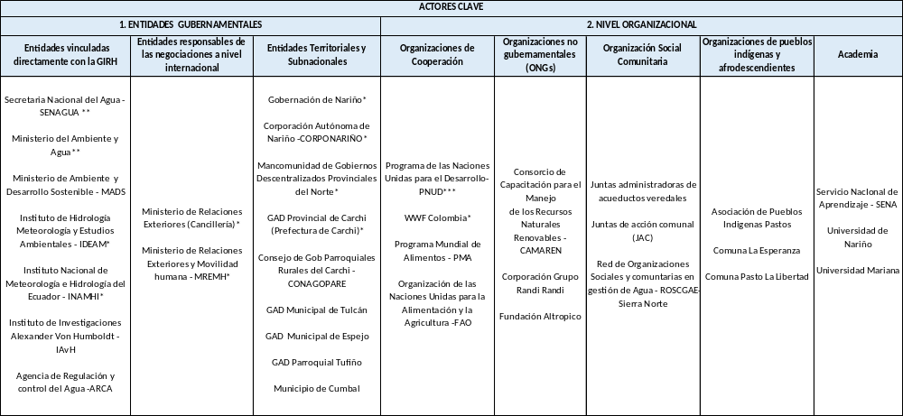

* Project partners
** Implementing Partner
*** Executing Partner
Annex 2. Key Stakeholders of the Mira Basin

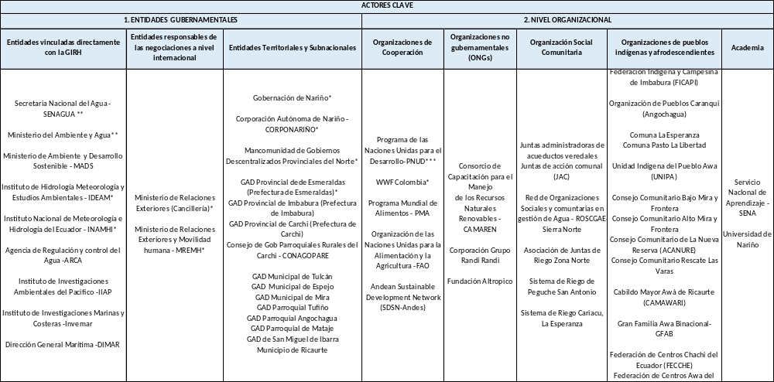

* Project partners
** Implementing Partner
*** Executing Partner

Annex 3. Key Stakeholders of the Mataje Basin

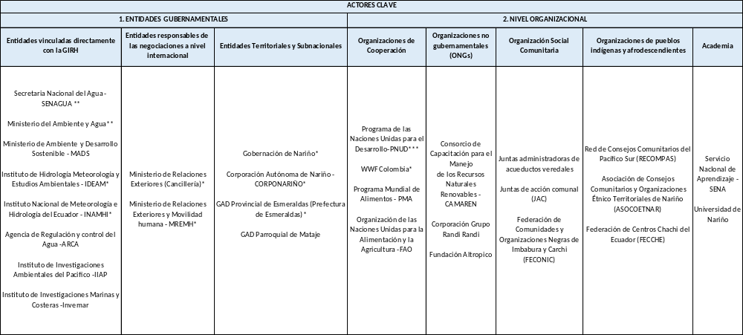

* Project partners
** Implementing Partner
*** Executing Partner

Annex 4. Key stakeholders of the pilot project on treatment plants

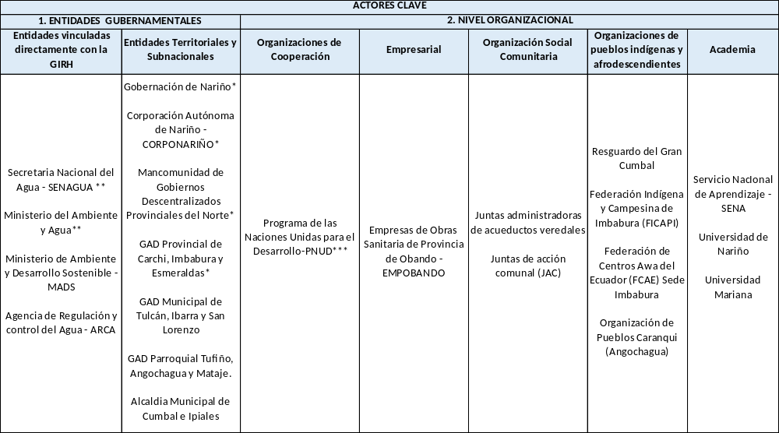
* Project partners
** Implementing Partner
*** Executing Partner
Annex 5. Key stakeholders of the pilot project on bioengineering community work

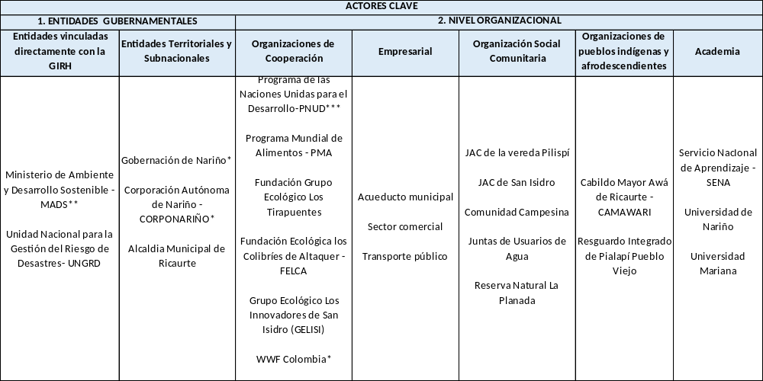

* Project partners
** Implementing Partner
*** Executing Partner
Annex 6. Key stakeholders of the hydro-meteorological network pilot project

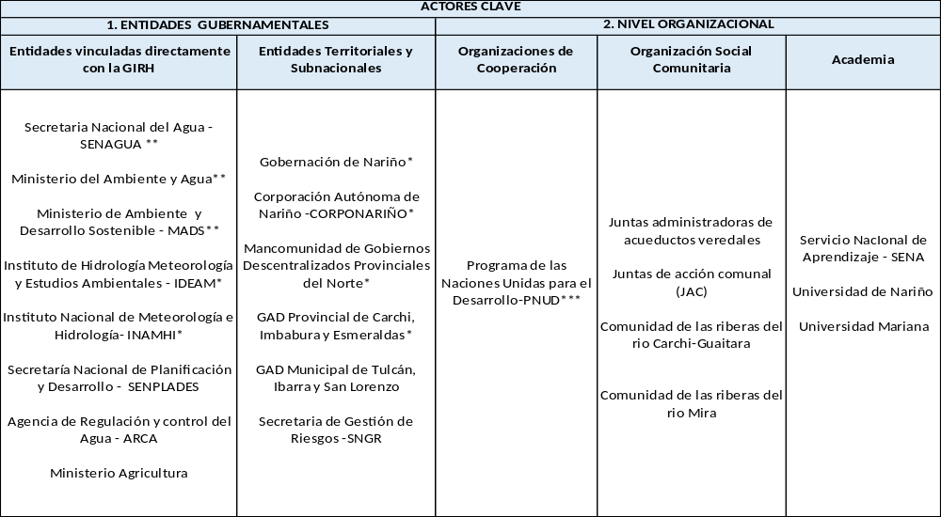
* Project partners
** Implementing Partner
*** Executing Partner
Annex 7. SEP Summary
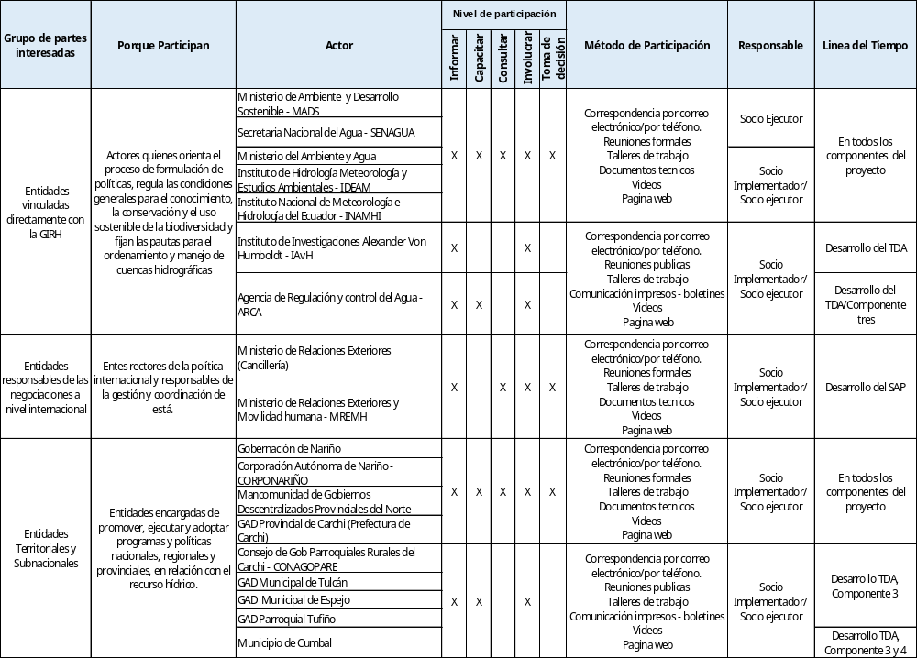
Continues
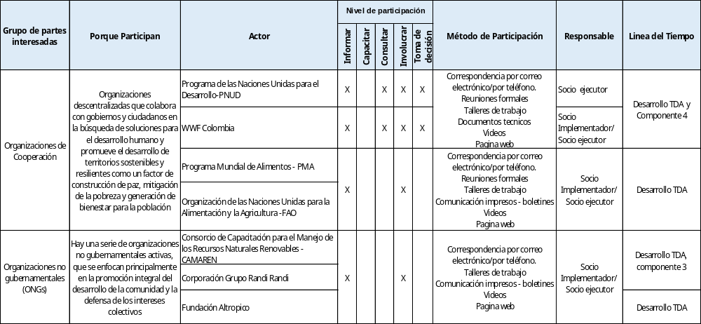

Continues

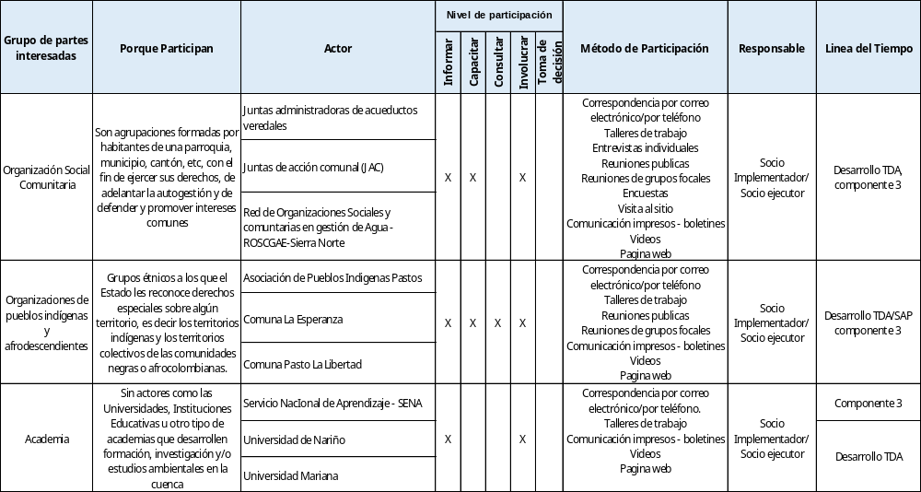

Vulnerability may be worsened because of discrimination for forbidden reasons such as race, ethnicity, gender, language, disability, sexual orientation, religion, political opinion or others, national, social or geographical origin.
Corponariño. 2016. Planes de Ordenamiento y Manejo de la Cuenca - POMCA Guaitara
Plan Binacional de Gestión Integral del Recurso Hídrico de las cuencas transfronterizas Carchi-Guáitara, Mira y Mataje Colombia- Ecuador: Síntesis. Tosse Luna Oscar (Minambiente, Colombia); Iza Cristian (Senagua, Ecuador). Bogotá, DC; Quito: Colombia. Ministerio de Ambiente y Desarrollo Sostenible; Ecuador. Senagua, 2017
Plan de Desarrollo y Ordenamiento Territorial - Carchi 2031
Pinilla, I. (Recopiladora). 2016. Memorias I Foro Binacional: Gobernanza, Servicios Ecosistémicos, Cambio Climático y Gestión Integral de las Cuencas Binacionales Mira y Mataje
Convenio 169, artículos 2.1; 6, b,c.
Decreto 1640 del 2012. Instrumentos para la planificación, ordenación y manejo de las cuencas hidrográficas y acuíferos
For more details see Stakeholder Analysis in the Carchi-Guaitara, Mira and Mataje basins.
UNDP. (2017). Guidance notes. UNPD Social and Environmental Standards. Standard 6: Indigenous Peoples.
UNDP. Stakeholders Response Mechanism: Overview and Guidance. (2014)
UNDP. Stakeholders Response Mechanism: Overview and Guidance. (2014).

